Tasmania has a higher diversity and number of internationally important bird sites relative to its size than any other Australian state, as well as the highest densities in Australia of a number of resident and migratory species. Tasmania, including Macquarie Island, provides breeding or foraging habitat for around 90 shorebird and seabird species.

Tasmania has a diverse shorebird fauna of 43 species, representing 64% of the shorebird species recorded nationally. During the summer migratory season, Tasmania has an estimated total population of 40,000 shorebirds. Many habitats that support Tasmania’s remarkable aggregations of shorebirds have been recognised as internationally renowned ‘Ramsar’[1] wetlands. Tasmania has a unique location at the southern extremity of the East Asian Australasian Flyway for migratory shorebirds. .

Not all of these species are doing well. Twenty-nine species consisting primarily of seabirds are listed as Threatened including 14 albatrosses, seven petrels, four terns, two cormorants and one prion. An additional albatross species and two subantarctic penguins not listed in Australia are Threatened at the global scale. Several shorebird species are of conservation concern.

**SHOREBIRDS**

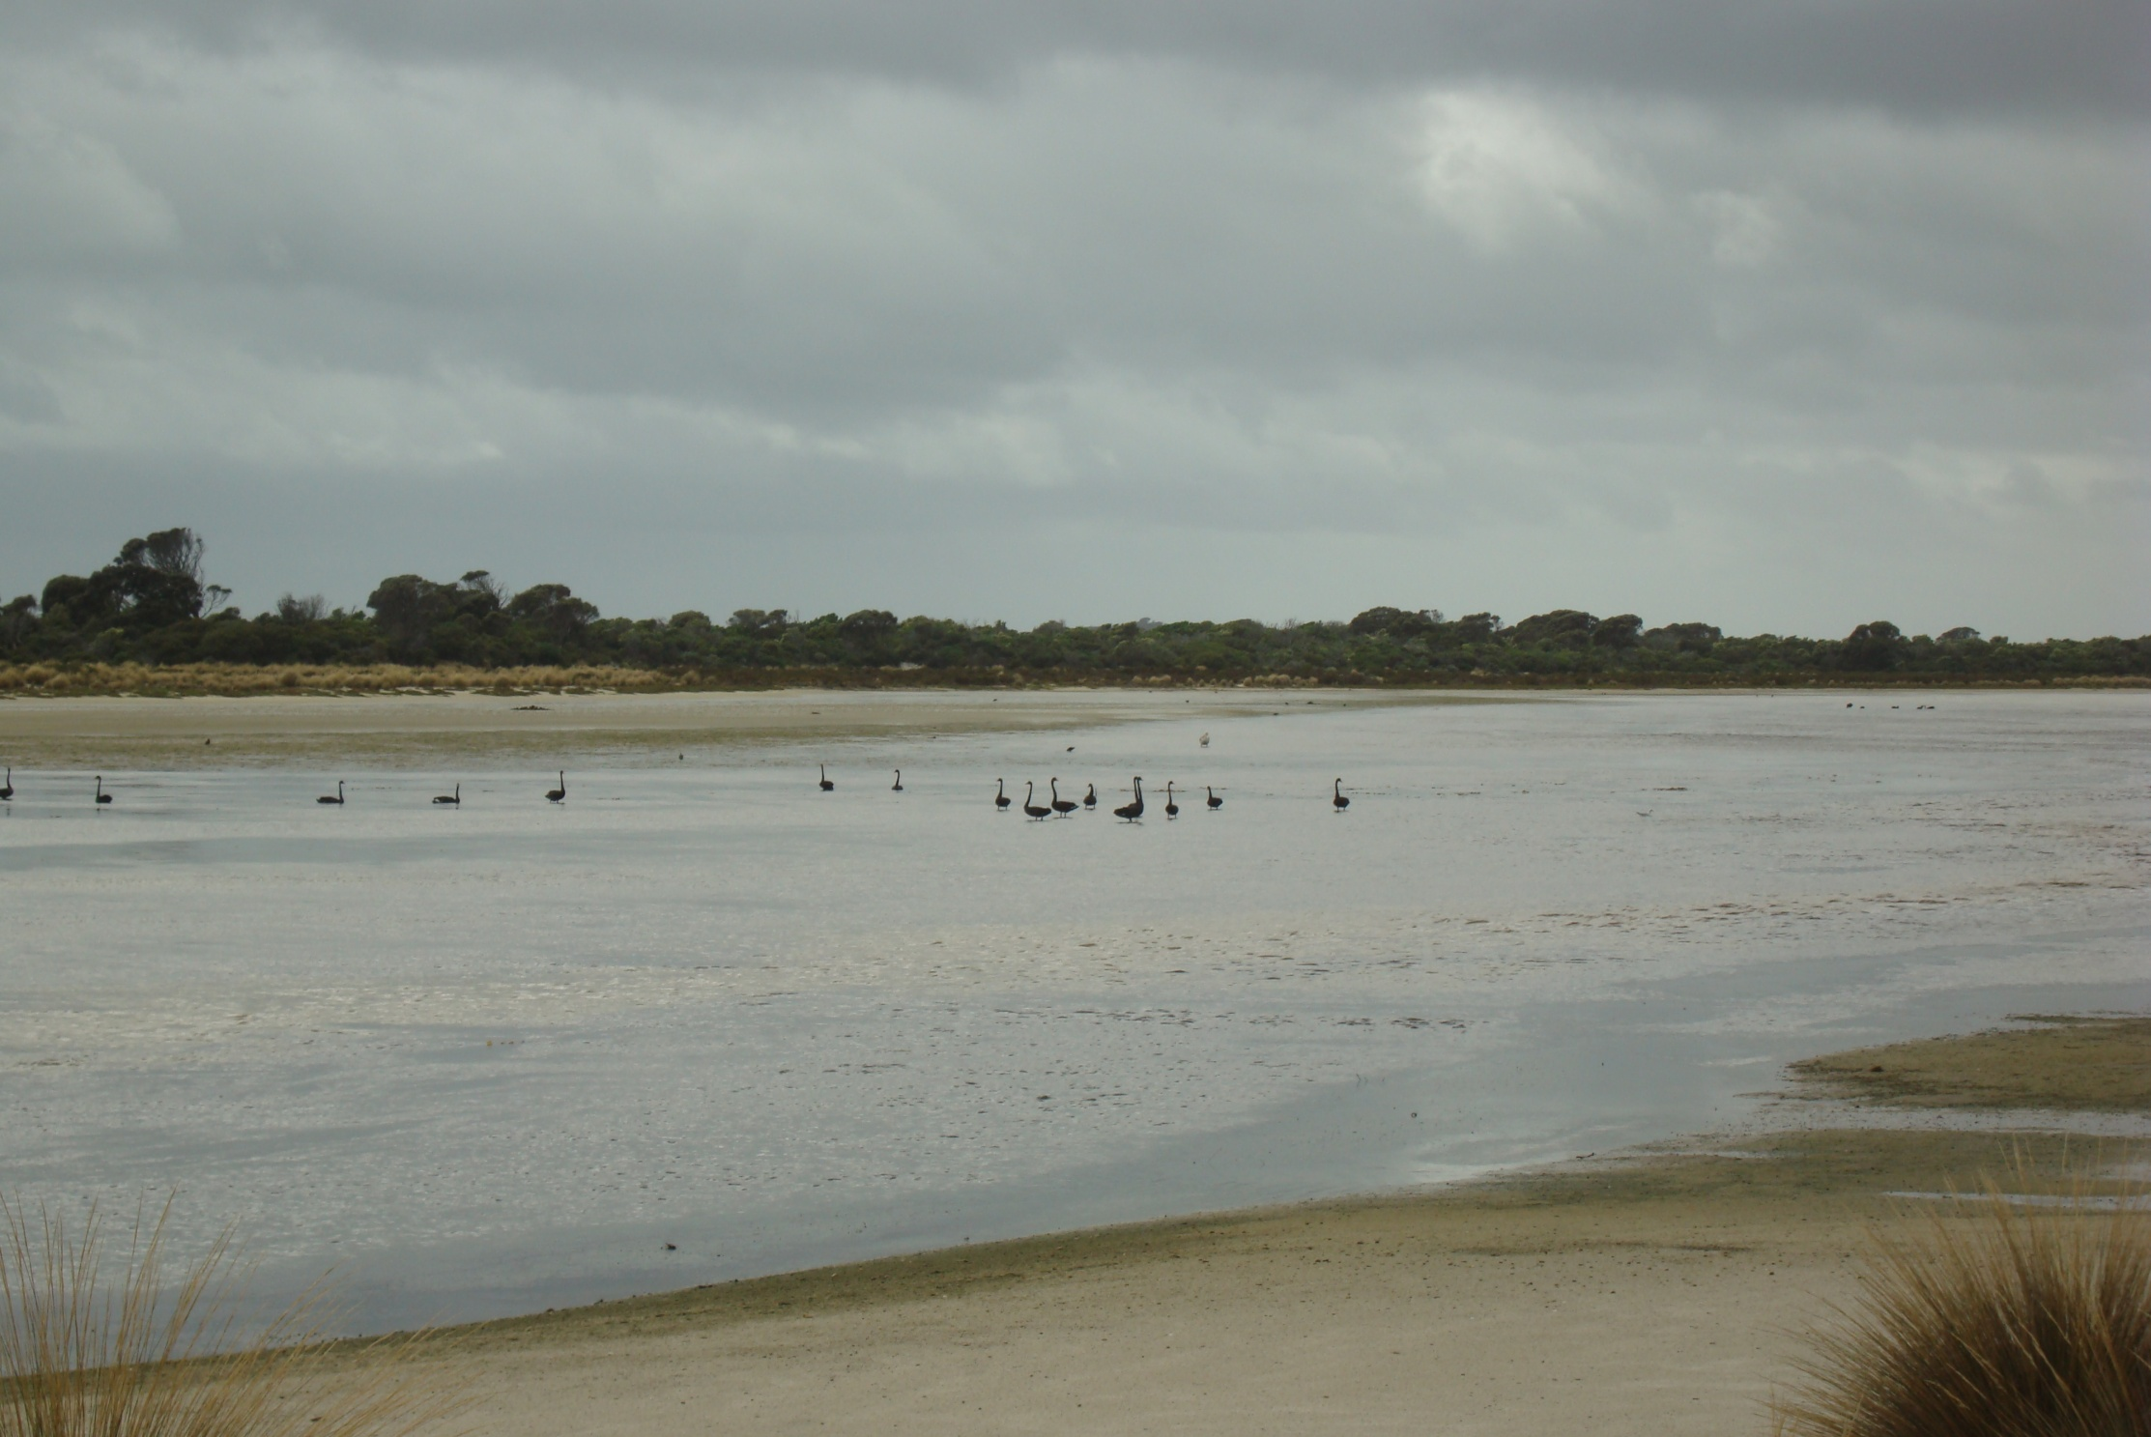

Black Swans, Little Musselroe River, M.Jacques

Tasmanian tidal flats provide year-round habitat for many shorebirds. The Tasmanian foreshore and islands are important feeding and breeding sites for pied oystercatchers (*Haematopus longirostris)* and many seabirds, including terns and gulls.

**Oystercatchers**

[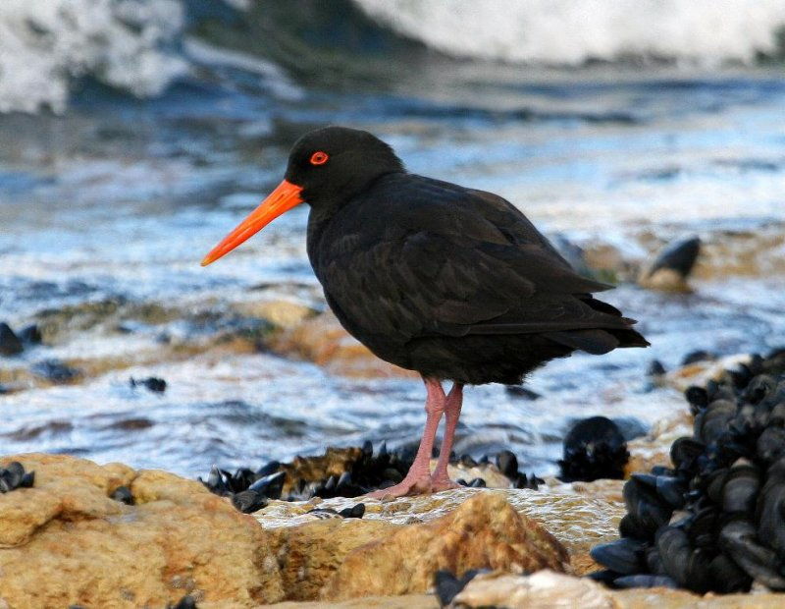](http://www.pbase.com/tassiebirds/sooty_oystercatcher)[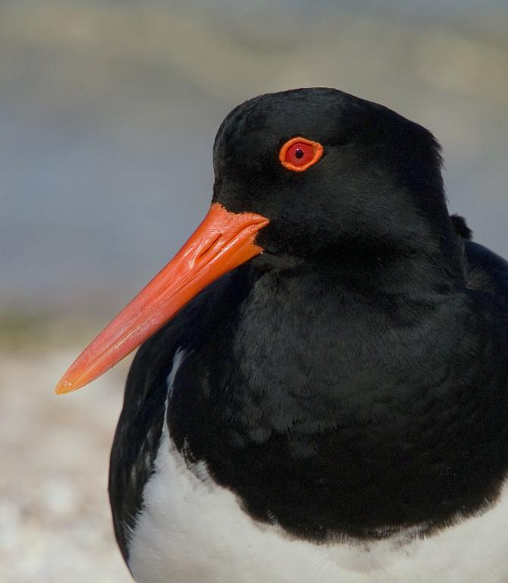](http://www.pbase.com/tassiebirds/pied_oystercatcher)

Sooty Oystercatcher and Pied Oystercatcher, Alan Fletcher

Tasmania is a stronghold for oystercatchers, containing the majority of the Australian population. The pied oystercatcher thrives on the many large tidal flats in the south-east, in large groups. Their beaks are specially adapted for searching through sand and silt. They chisel open clams and other small shellfish. Sooty oystercatchers prefer to be in pairs or small groups and specialise in eating shellfish growing on rocky platforms.

They can only feed at low tide and the rush is on to catch enough food for the day. They are easily disturbed by dogs and humans.

**White faced heron**

***Egretta novaehollandiae***

The whited faced heron is quite adaptable, able to hunt for frogs and insects in inland fields, as well as wading through coastal shallows to catch fish.

Jun Zhang

[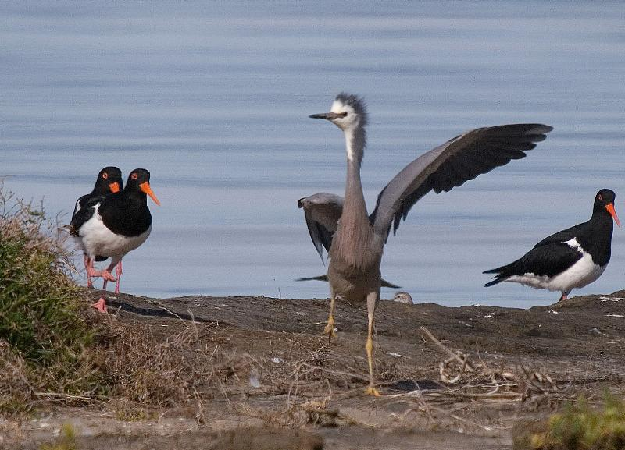](http://www.pbase.com/tassiebirds/whitefaced_heron)

Alan Fletcher White-faced heron being chased off by grumpy breeding pied oystercatchers.

**Hooded plover *Thinornis cucullatus***

Alan Fletcher

These little birds prefer beaches that are undisturbed by humans, dogs and feral animals. Disrupted breeding has led to the bird being listed as vulnerable. About 7000 remain across Australia. From August to March they lay a small clutch of eggs in the dry sand. It eats insects, shellfish and small sandhoppers.

**Sanderling *Calidris alba***

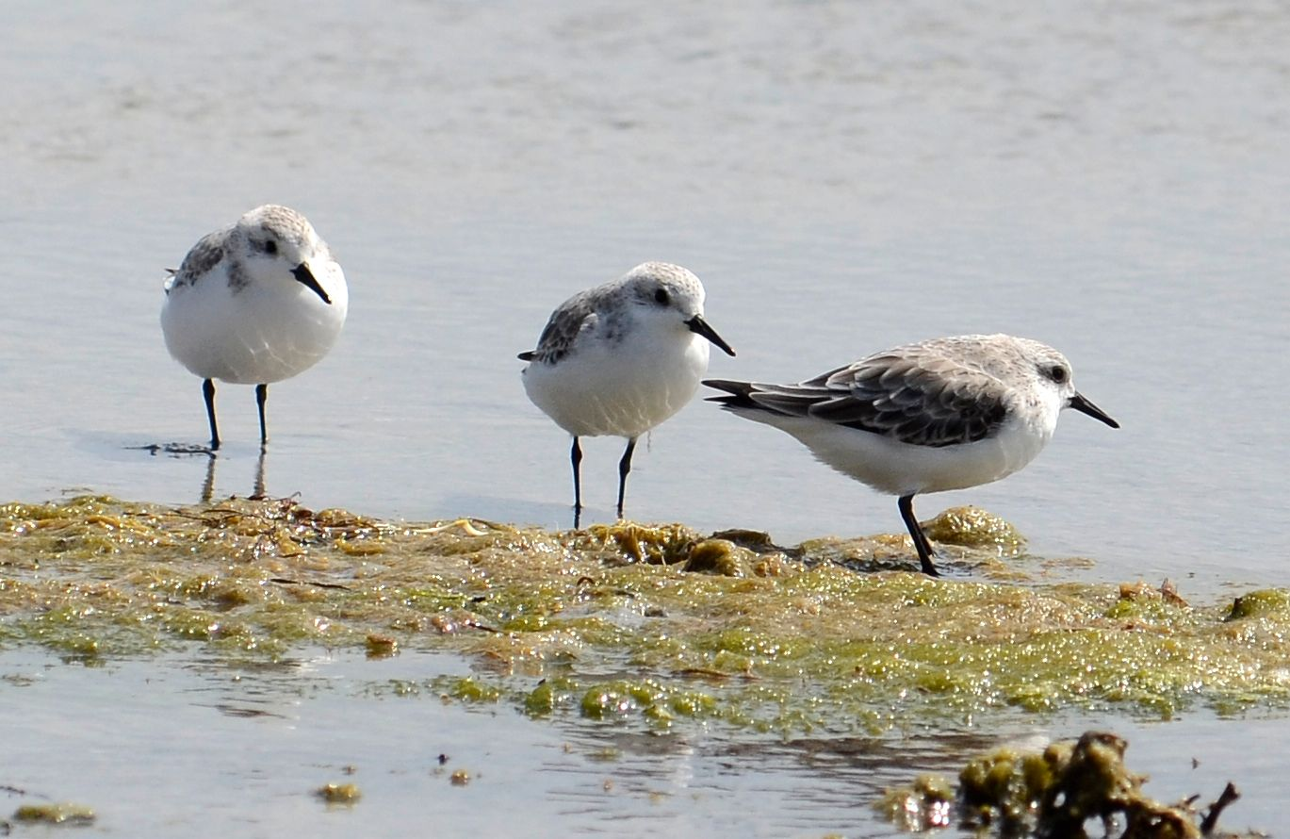

Dr Eric Woehler

They can be spotted only when they move as they are very well-camouflaged against the wet sand. They arrive in the Australian summer and fish for crabs and small crustaceans. These birds travel to the Arctic in the southern autumn/northern Spring. As it cools in Siberia, they fly 10000 kms to the southern hemisphere.

**SEABIRDS**

**Australasian gannet *Morus serrator***

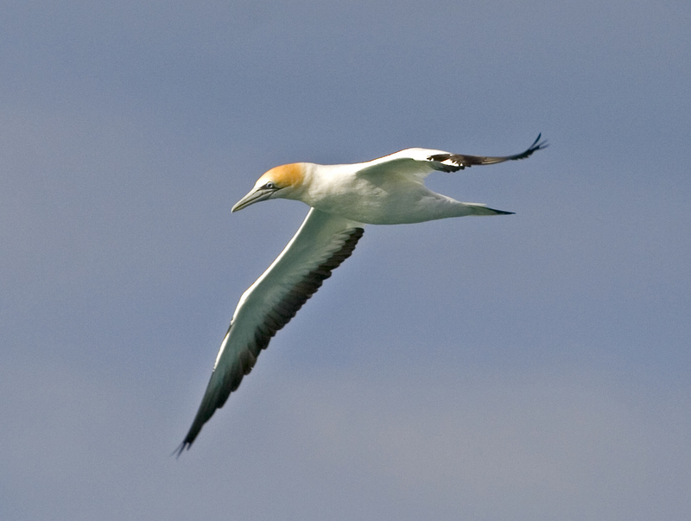

Alan Fletcher

These birds are often seen diving into the water to hunt squid and school fish. They mostly nest in offshore islands.

In Tasmania, there are colonies at [Eddystone Rock](https://en.wikipedia.org/wiki/Eddystone_(Tasmania)), [Pedra Branca](https://en.wikipedia.org/wiki/Pedra_Branca_(Tasmania)), and [Black Pyramid Rock](https://en.wikipedia.org/wiki/Black_Pyramid_Rock). The colony on Black Pyramid grew from 500 pairs in 1961 to 12,300 pairs in 1998. Eddystone Rock increased from 20 pairs in 1947 to 189 pairs in 1998, and Pedra Branca grew from 1000 pairs in 1939 to 3,300 pairs by 1995. Balancing this up, the colony at Cat Island has been abandoned due to predation.

**Silver gull *Chroicocephalus novaehollandia***

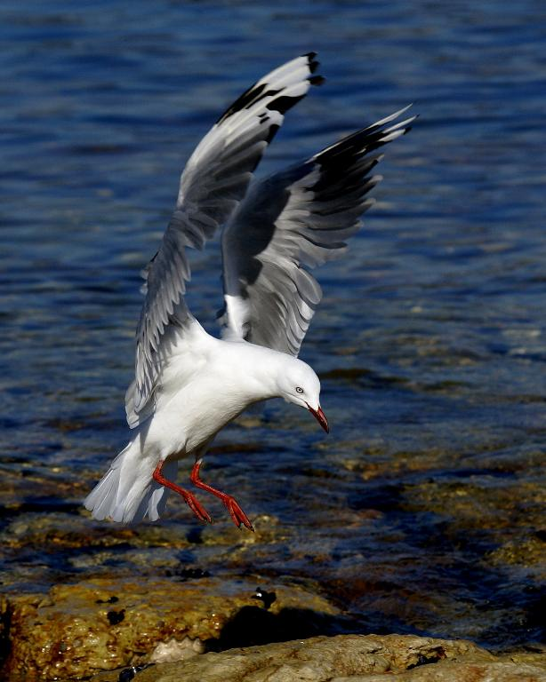

Alan Fletcher

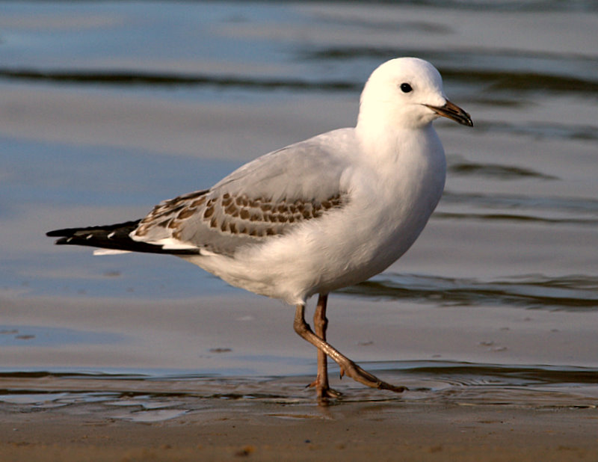

Alan Fletcher

The silver gull in present in large numbers near cities (about 12000 in the South East alone) as they have adapted well to wasteful human behaviour. They have been called ‘rats of the skies’ and are thought of as vermin, when they are just intelligent and resourceful exploiters of our excesses. They can adapt to any new food source. Thousands now aggregate near fish farms. They have also been seen chasing wasps, eating road kill, and even waiting at a glass recycling conveyor belt, to pick food scraps off broken jars. In their natural habitat they can be seen disturbing the sand with their feet to pick up amphipods and juvenile fish.

Their numbers are a good indicator of our bad behaviour, and one of the longest running bird censuses in the world, is the winter gull count run by Birdlife Tasmania.

**Kelp Gull *Larus dominicanus* INVASIVE**

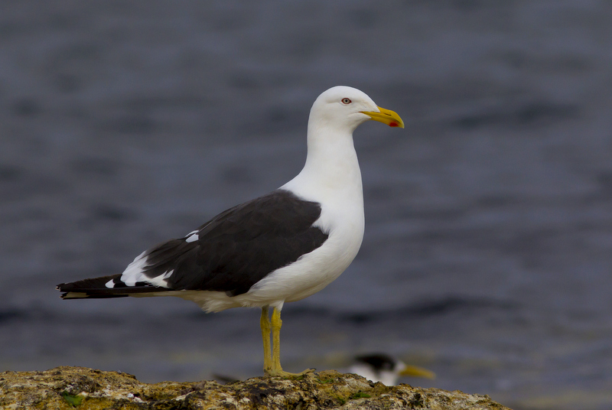

Alan Fletcher

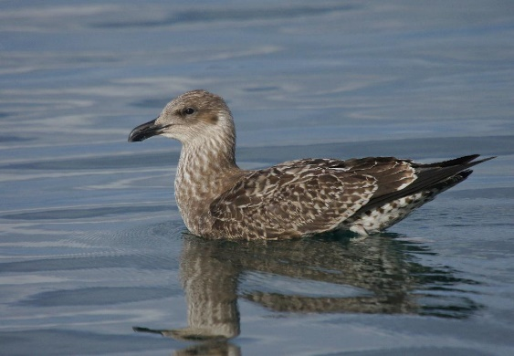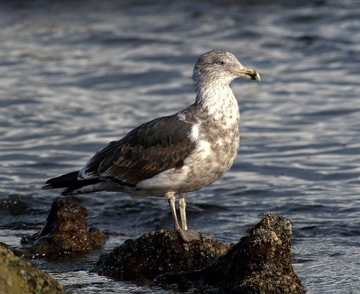

Alan Fletcher, one and two year juveniles

This gull has moved all over the world, following the new opportunities offered by humans. It is a large and aggressive gull that can push other birds out of nesting sites. It will try anything, including biting chunks of flesh off surfacing whales. When Tasmanian tips started to be better managed, they moved off to fish farms, where they grab any floating fish food that doesn’t immediately get eaten by salmon. There are about 5000 birds in the South East, and they are now spreading around even remote parts of Tasmania.

**Pacific Gull *Larus pacificus***

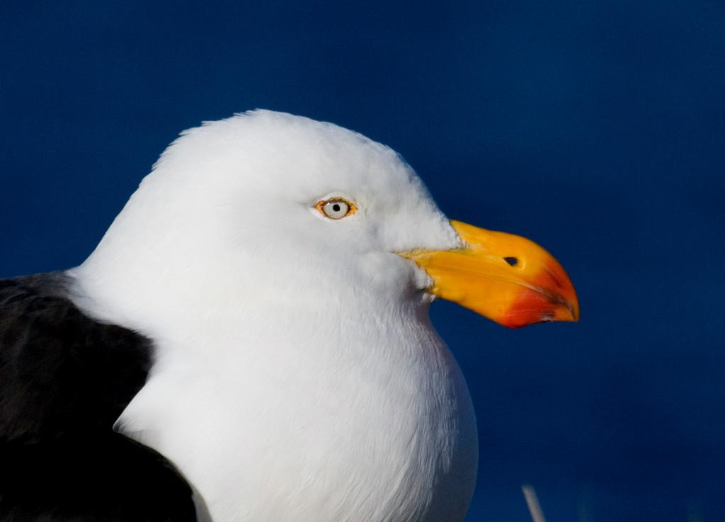

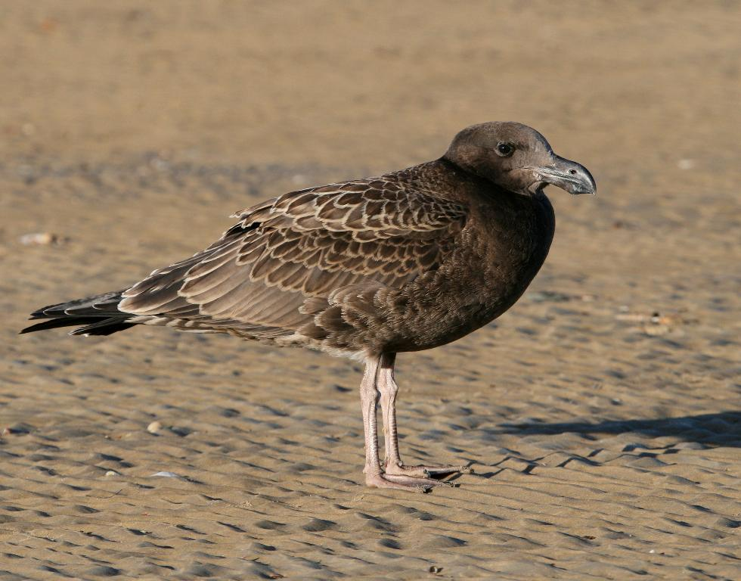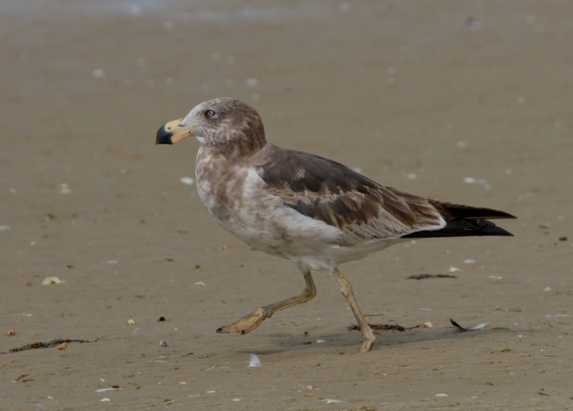

Alan Fletcher, 1 and 2 year juveniles are shown below

These generally quiet and harmless gulls can be seen along Tasmanian beaches, usually in pairs. Despite being larger than the kelp gull they can get pushed around by other gulls. They are distinguished from the kelp gull by their overall large size and red ‘lipstick’. The Pacific Gull has a red tip on both halves of its thick beak, while the kelp gull has a red tip only on its slim lower beak.

Other gulls have counts in the tens of thousands, but there are only about 800 Pacific Gulls in South East Tasmania, still a big improvement from the 1980s.

**Cormorants**

Tasmanians seem to have the idea that these birds compete for fish supplies and are an introduced pest. As late as the 1950s bounties were offered for shooting them. They are NOT introduced. Some species are widespread across the world, and others are quite rare in Tasmania. Some of them stick to the coast and only some cormorants like to raid inland fish farms.

**Great Cormorant *Phalacrocorax carbo***

[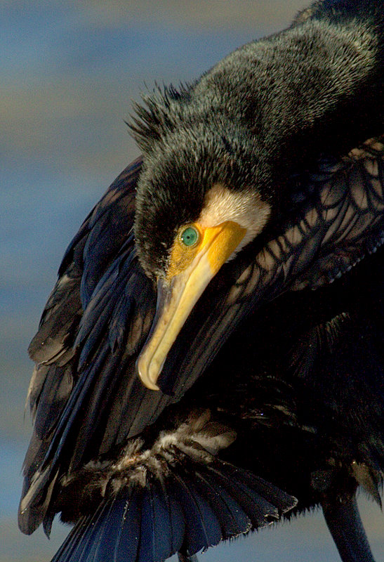](http://www.pbase.com/tassiebirds/great_cormorant)The Great Cormorant is a worldwide species. The subspecies found in Australasian waters, *P. carbo novaehollandiae,* has a crest.

Alan Fletcher

The Great Cormorant breeds mainly on coasts, nesting on cliffs or in trees. The Great Cormorant can deep dive, but often feeds in shallow water. A wide variety of fish are taken. Dive times of 20–30 seconds are common, with a recovery time on the surface around a third of the dive time.

There are now increasing numbers of birds breeding inland to take advantage of human food sources, and many inland fish farms and fisheries in Europe claim to be suffering high losses due to these birds. They can still be legally shot in some European countries and are illegally shot here.

**Little Pied Cormorant**

***Microcarbo melanoleucos***

[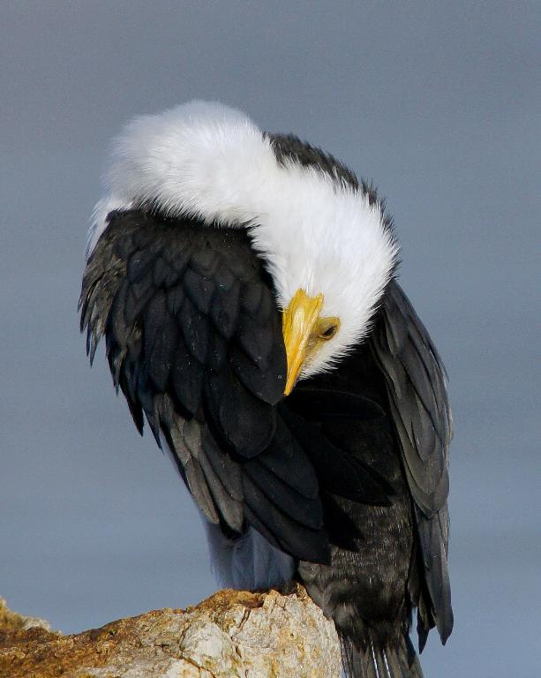](http://www.pbase.com/tassiebirds/little_pied_cormorant)This is a common waterbird, found around the coasts, islands, estuaries and inland waters.

The Little Pied Cormorant resembles the Pied Cormorant, *Phalacrocorax varius*, but is distinguished by its smaller size and shorter bill. It doesn‘t have Pied Cormorant‘s orange yellow face patch and black thighs.

Alan Fletcher

The Little Pied Cormorant is at home in either fresh or salt water. It is often seen in large flocks on open waterways and on the coast, especially where large numbers of fish are about. On inland streams and dams it is often solitary.

The Little Pied Cormorant finds its prey on the sea floor, mainly crabs. On inland streams and dams they catch yabbies. Eels and insect larvae are also eaten. The bird will sometimes put a fish down on the surface of the water to swallow it head first. Because of this habit, they are sometimes followed by gulls trying to snatch an easy meal.

**Shy Albatross**

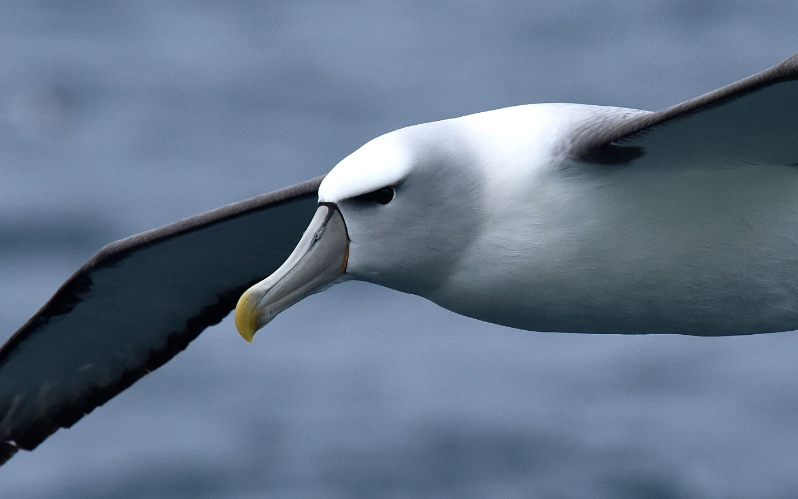

Photo Dr Eric Woehler

The shy albatross is the only albatross species totally unique to Australia. Shy albatross (*Thalassarche cauta*) are less ocean-roaming than other albatross. They are often seen by boaters in Bass Strait, and tend to remain relatively close to their breeding sites at Albatross Island off Tasmania’s north west, and Mewstone and Pedra Branca off the Tasmanian south coast. While they don’t roam as much as other albatross they will still forage as far as South Africa.

**White bellied sea eagle *Icthyophaga leucogaster* VULNERABLE**

There are fewer than 1000 adult birds in Tasmania. In Tasmania it is threatened by nest disturbance, loss of suitable nesting habitat, shooting, poisoning, trapping, and collision with power lines and wind turbines. The species can be easily disturbed by humans, especially when nesting, and may desert nesting sites. It is found in greater numbers in areas with little or no human impact or interference.

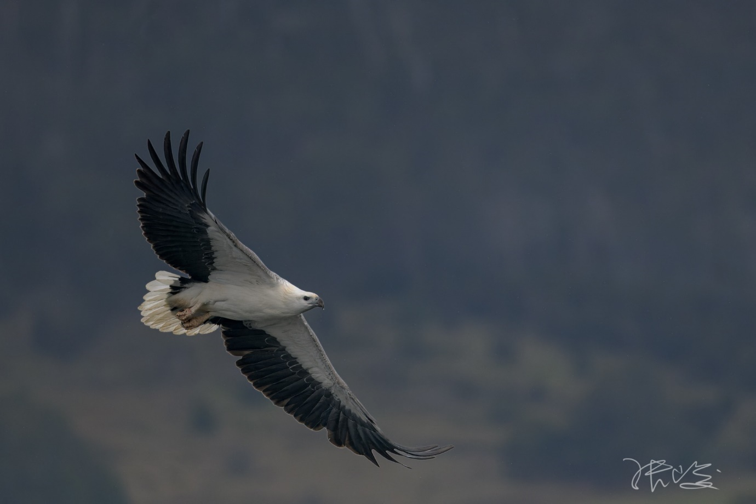

Photo Jun Zhang

**Migratory shorebirds**

Migratory shorebirds escape the harsh northern winter in the Arctic to feed and rest in Australia and New Zealand. Birds make an amazing annual round-trip migration of some 25 000 km on the East Asian – Australasian Flyway. Some fly for more than 10 000 km non-stop from areas in Siberia and Alaska. Tasmania’s tidal inlets are a critical feeding site for weary travelers.

A total of 32 species of migratory birds visit in the tens of thousands. Mutton birds arrive in the millions.

Annual international visitors such as the eastern curlew (*Numenius madagascariensis)*, bar-tailed godwit (*Limosa lapponica),* and red-necked stint (*Calidris ruficollis)* can often be seen foraging on the mud and sand flats during the summer.

**Grey-tailed tattler *Tringa brevipes***

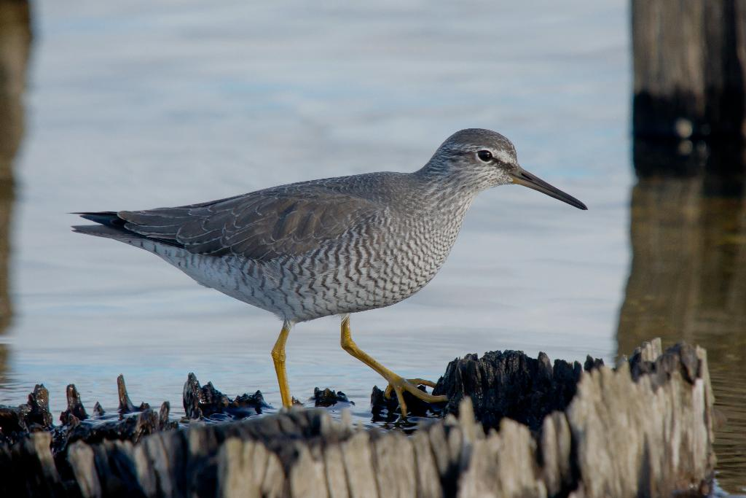

Alan Fletcher

Grey-tailed tattlers migrate to Tasmania every year from breeding grounds in Siberia. They don’t usually get together in large flocks. The birds forage on the ground or in the water for insects, crustaceans and other [invertebrates](https://en.wikipedia.org/wiki/Invertebrate).

**Eastern curlew**

***Numenius madagascariensis***

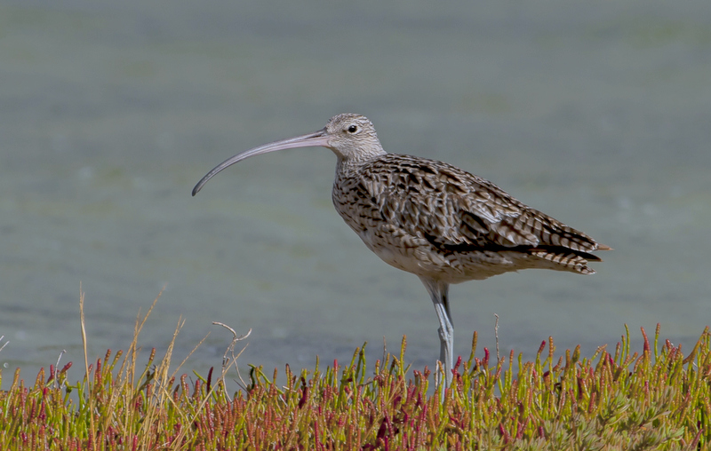

Alan Fletcher

This is the largest migratory bird to visit Tasmania. 75% of the world population with stop over in Australia during their migration from the northern hemisphere. They get their name from the sound of their call. Their bill is adapted to catch their favourite food, crabs.

**Crested tern *Thalasseus bergii***

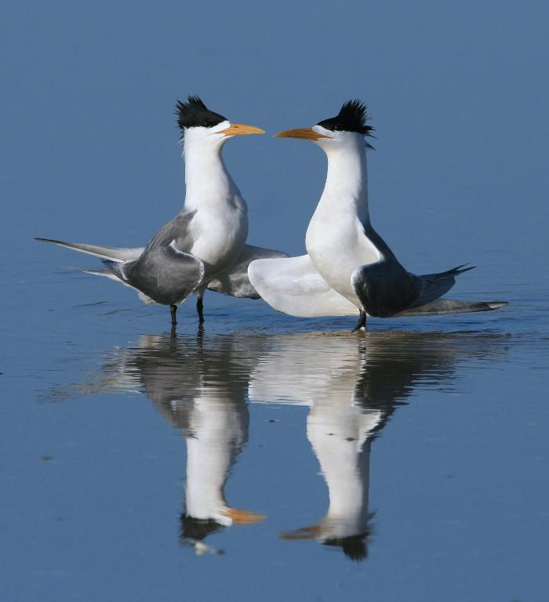

Alan Fletcher

This tern can be identified most of the year from its shaggy crest. This disappears in winter. It travels far and wide and is quite adaptable, even nesting in human structures.

**Fairy tern *Sternula nereis***

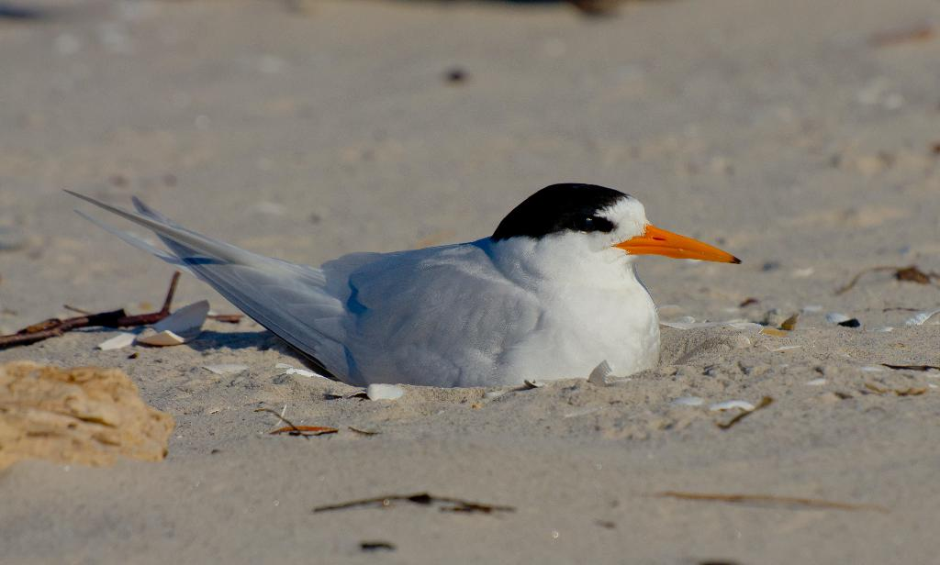

Alan Fletcher

While the crested tern is pretty common, the fairy tern is not. It is sometimes seen hovering over the surface looking for schools on bait fish to dive on. It will try to lay eggs on the dry sand of beaches, areas that are increasingly disturbed by humans. While its numbers are still high globally, they seem to be dropping fast. In NZ they have been close to localised extinction for decades, now down to 40 birds.

**Mutton birds/short-tailed shearwater *Ardenna tenuirostris***

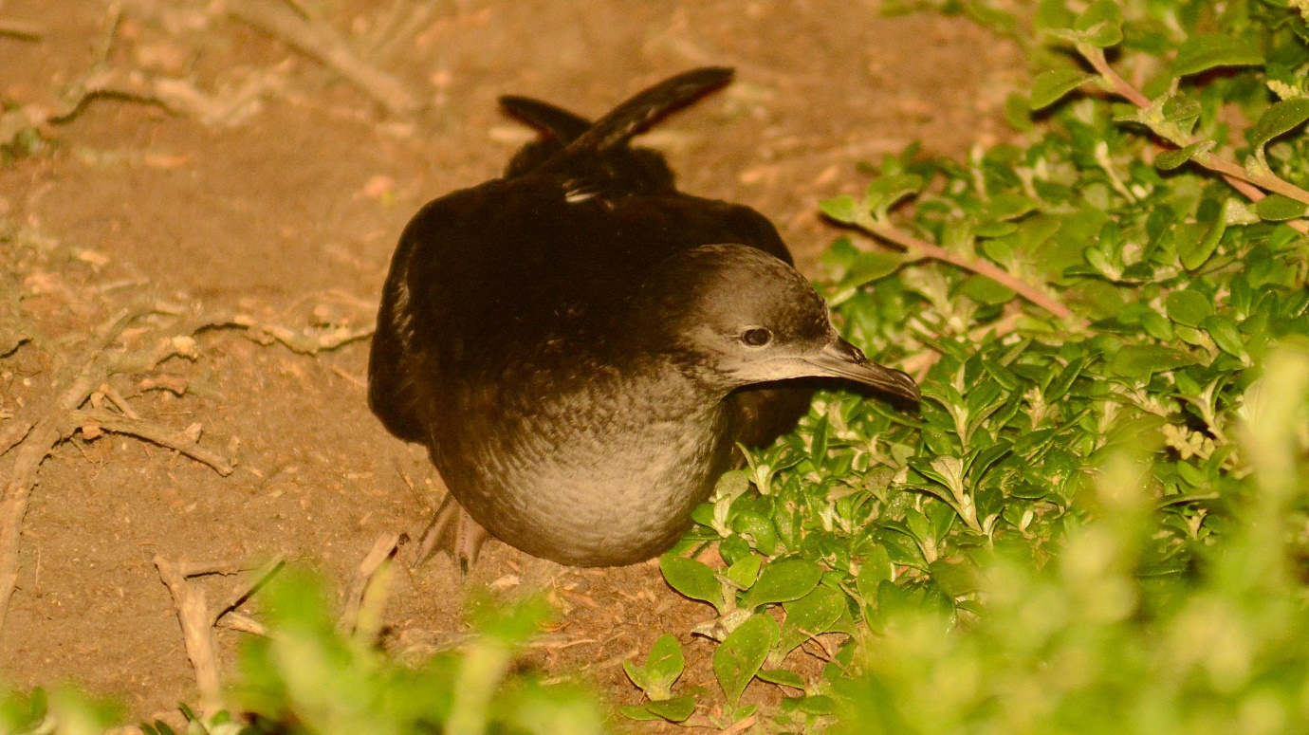

Dr Eric Woehler

One of the great wildlife spectacles is the arrival of mutton birds to Tasmania. During the Artic summer they fish off Siberia and Alaska before flying down the American coast to California. Then they cross the vast open expanses of the Pacific to reach Australia. Its one of the longest migrations in the world, at about 1500 kms. They arrive in Tasmania, almost like clockwork, and huge flocks can be seen in Bass Strait. They are common in the offshore islands of Bass Strait, and at the Great Dune on Bruny Island. About 2.8 million pairs will set up burrows on Babel Island near Flinders Island. They will also occupy small rookeries at many other sites along the coast. They are still hunted by Tasmanian Aboriginal people, which is a long-standing cultural practice. Although common, they can fall foul of plastic pollution and artificial lights.

**Little penguin Eudyptula novahollandiae**

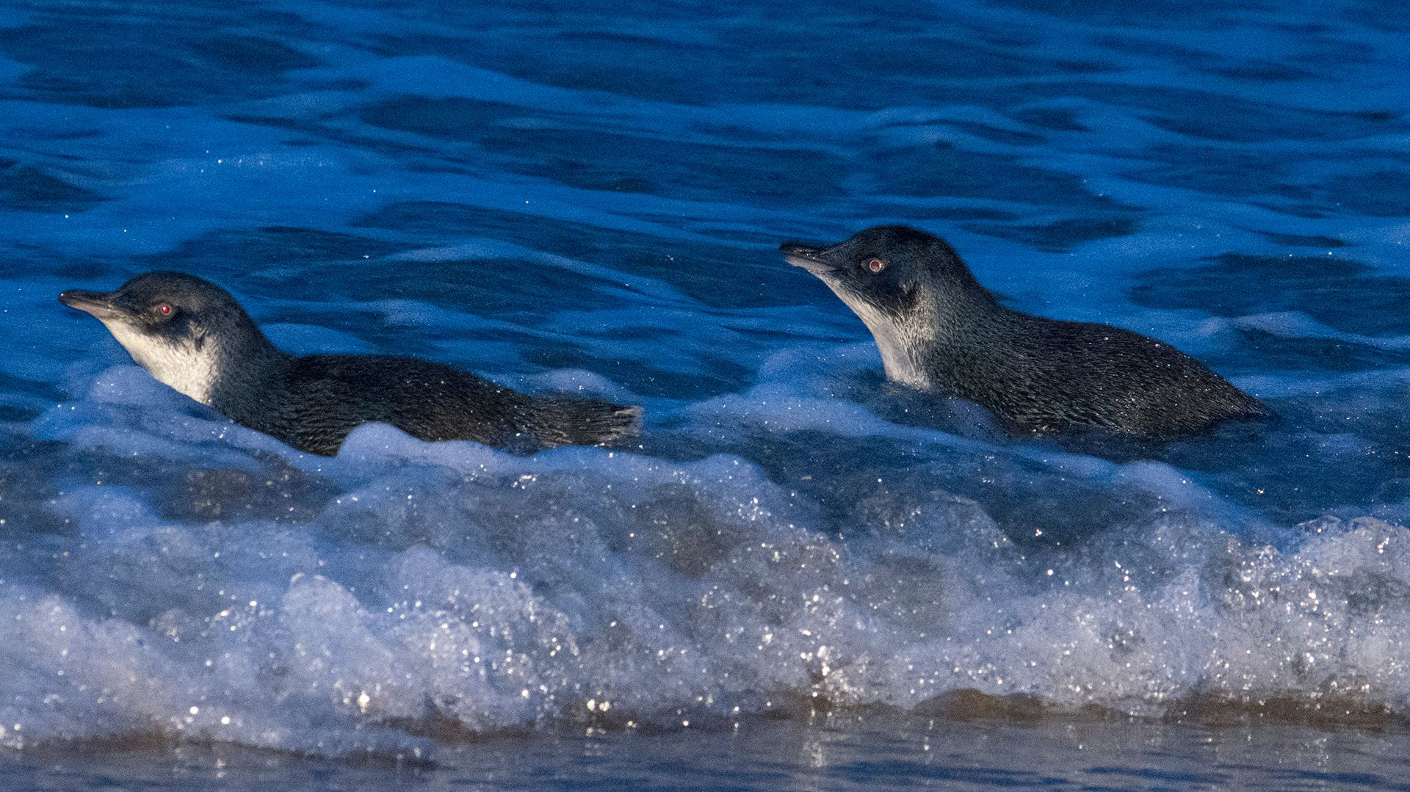

Photo Dr Eric Woehler

The little penguin was previously known as the fairy penguin. Tasmania is a stronghold of the species with up to 190 000 birds. Once rarely seen on the mainland they have become more common in places like Bicheno. Little penguins eat 76% small fish and 24% squid. They will eat whatever is available but often pilchards and anchovies. They will change diets, as they were forced to do after big sardine mortality events in the 1990s. They are vulnerable to netting as they fish inshore, often in water no deeper than 2 metres. They prefer short dives, but can stay underwater for 90 seconds. Their maximum recorded dive is 66.7 metres.

Little penguins come ashore to breed, and return to large colonies in places like, Fortescue Bay, Low Head, Lillico Beach, the Great Dunes, Bicheno, and even Blackmans Bay in Hobart. Some of these areas are open for public tours. They are vulnerable to dog attacks and do better in fenced reserves.

1. Rasmsar is the place where this international treaty was signed.