**OCEANWATCH – Having fun while helping the Ocean**

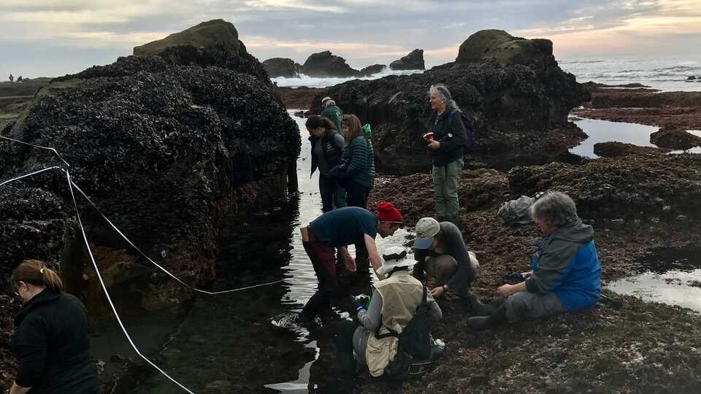 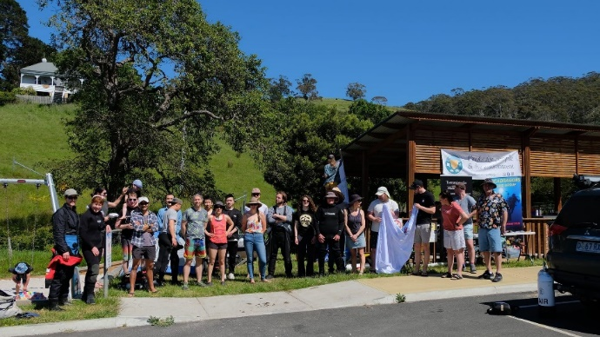

What is it about?

* Oceanwatch is a citizen science program that is an easy way to have some fun and help the ocean.
* Lots of ocean areas have no information about what lives there.
* You can help the ocean while meeting people, having fun with the kids, or even taking the dog for a walk.
* It’s for the young or young at heart.
* We are going to collect information on the animals and birds, pick up rubbish, share information on fun sightings, and report on issues as we seen them.
* You can even do some surveys of the reef, we will show you how.
* It is going to help make you and your family healthier, happier and more informed.
* Its for volunteers, people who care about the ocean and want to learn more. Events are free.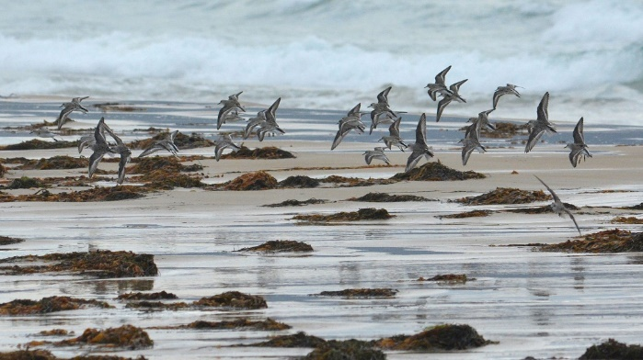

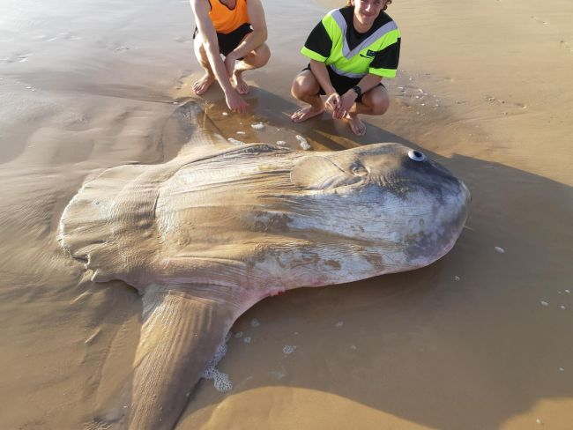

We will be asking expert mentors to come along and help you get started.

It’s a great place for questions, and there are no silly questions. Bring a snorkel, kayak or any other gear you like. Bring your own personal needs like water, sunscreen, hat and maybe a mat or knee pads. The only risks are tripping and slipping, so just be careful.

It doesn’t matter that you don’t know anyone or anything, be curious! [www.marinelife.org.au](http://www.marinelife.org.au) or [www.marinelife.org.au](http://www.marinelife.org.au) / [“Tasmanians for Marine Parks”](https://www.facebook.com/Tasmanians-for-Marine-Parks-535390010713276/) on Facebook Email us at [marinelifetassie@gmail.com](mailto:marinelifetassie@gmail.com) or at [Moremarineparks@gmail.com](mailto:Moremarineparks@gmail.com)

See forms and links to detailed information at <http://marinelife.org.au/?page_id=2891>

Photos: Dr Eric Woehler, livescience, California Academy of Sciences