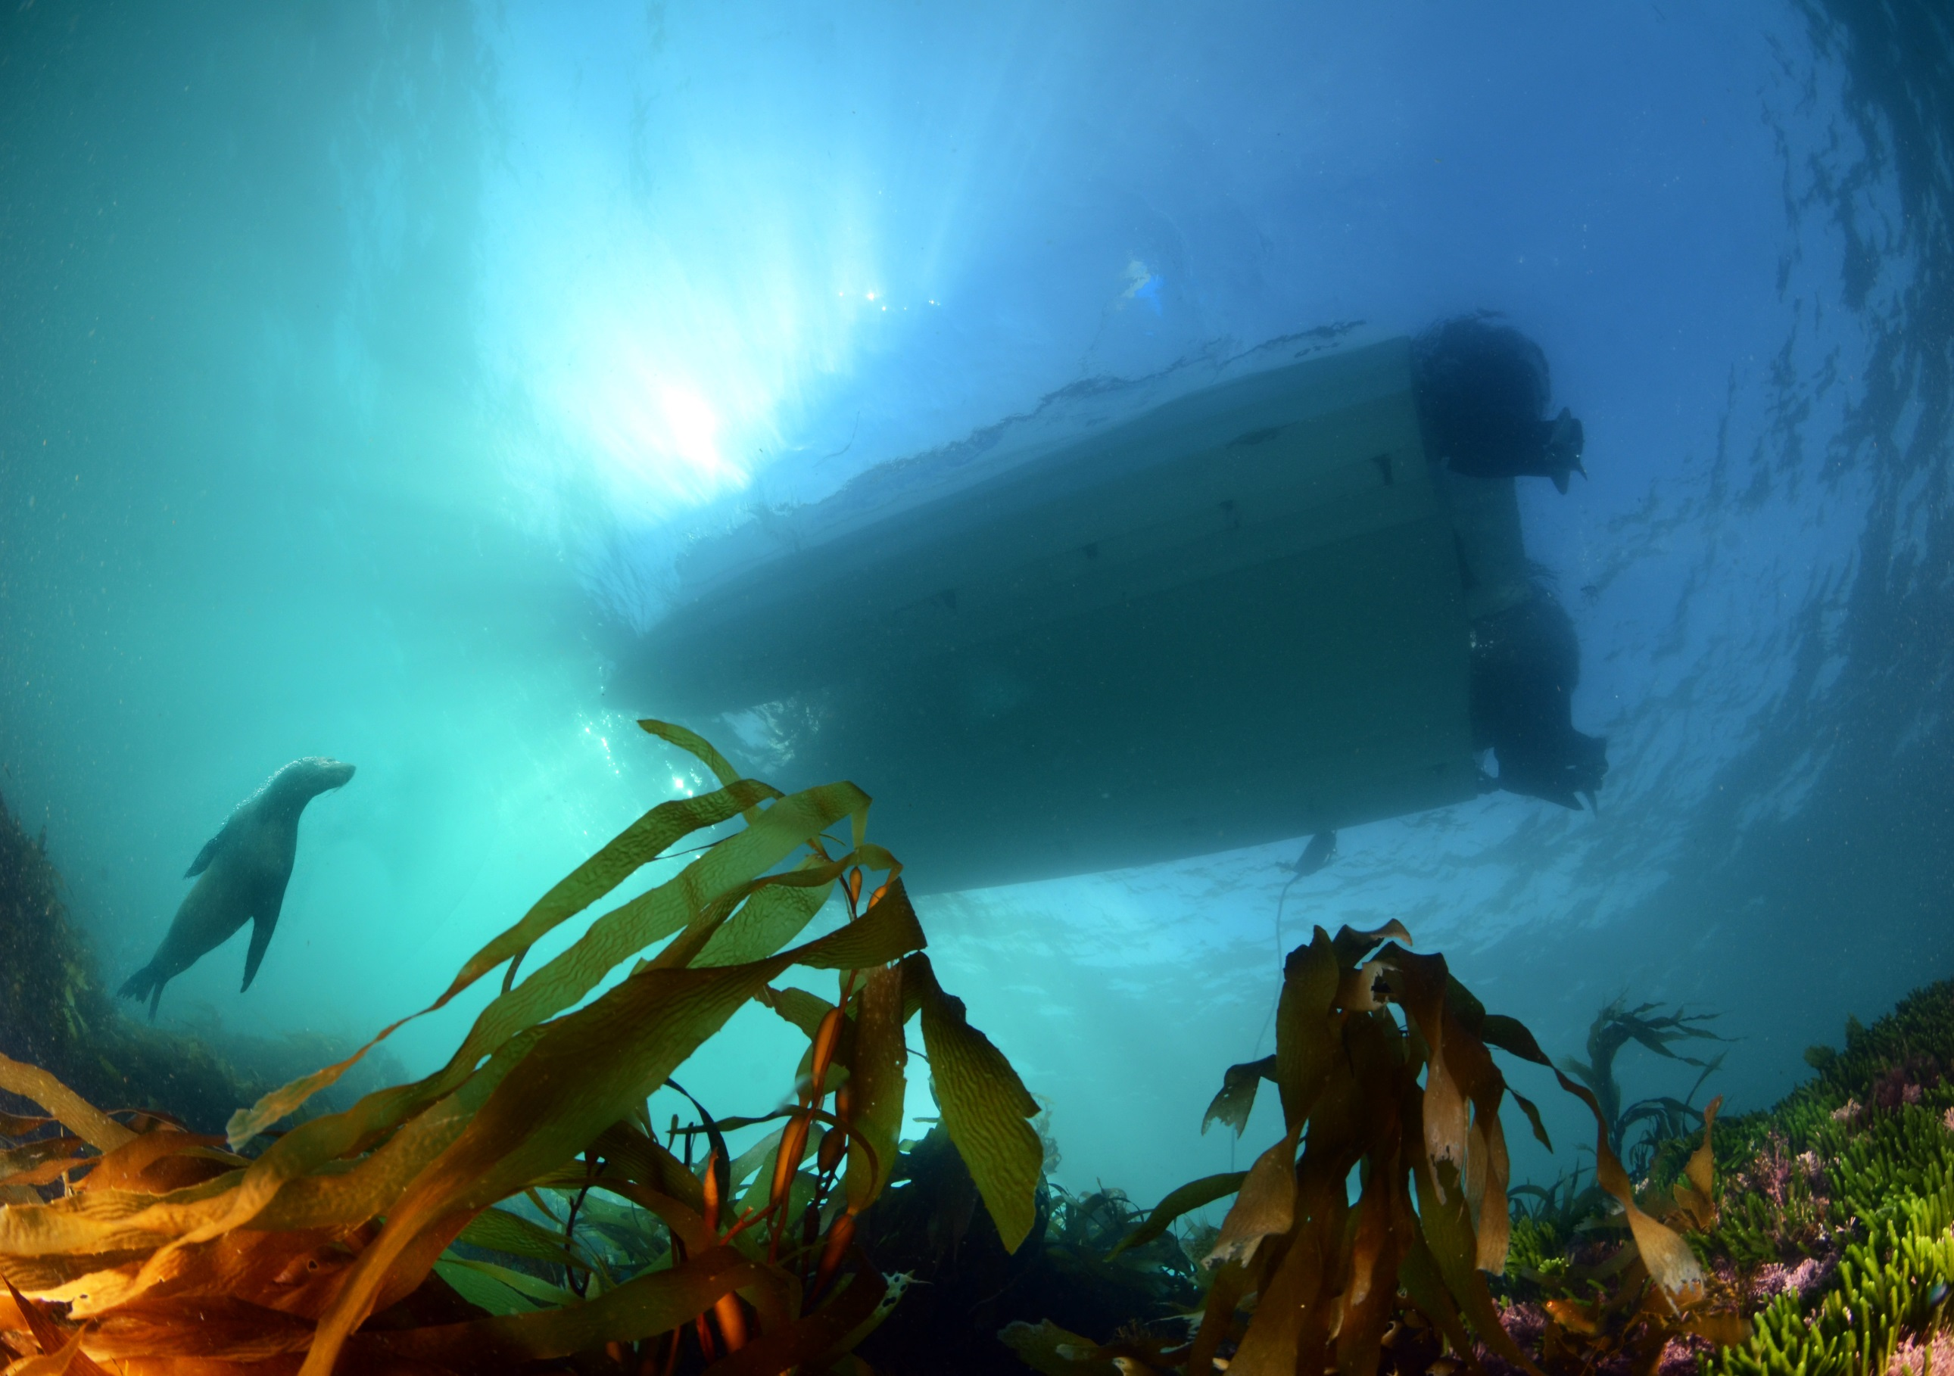MARINE Life

**June July 2018**

# **Oil and the Bight**

Source ABC

***Energy companies are eager to explore what resources the area has to offer.***

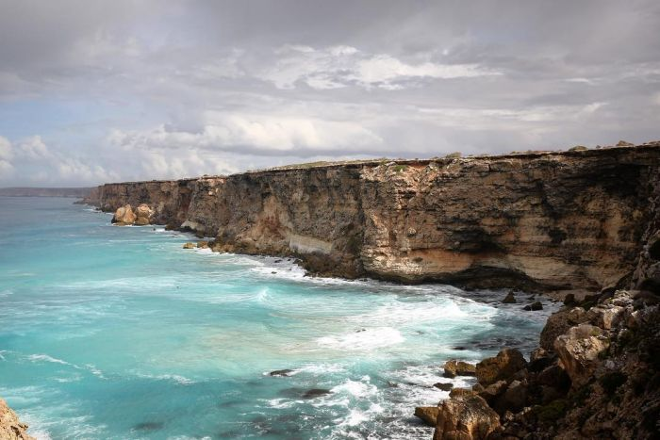 [*Marian Martin*](http://www.abc.net.au/news/2018-05-05/the-bight-beckons/9726810)

The Great Australian Bight spans 40,000 square kilometres of deep ocean off the coast of Southern Australia. The Bight contains more endemic marine diversity than the Great Barrier Reef.

But the area may also have oil. Between 1972 and 2003, the Federal Government issued 45 permits for oil and gas exploration in the Great Australian Bight, but in 2015 plans by BP have caused debate.

Environmental groups argue an oil spill would decimate the marine environment and devastate coastal communities as far as Tasmania and Victoria.

But oil companies believe there's huge potential for job creation and exploration can be done safely.

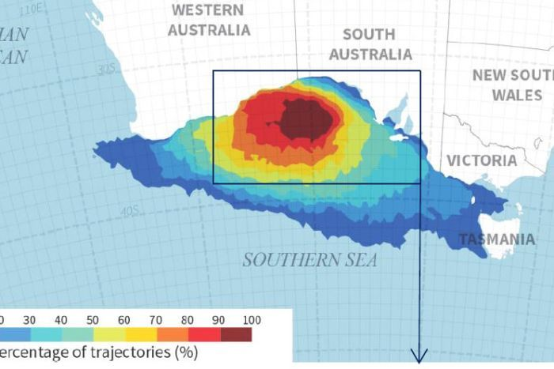

[*Wilderness Society Modelling of where an oil spill could extend*](http://www.abc.net.au/news/2018-05-05/modelling-of-where-an-oil-spill-might-reach-in-great-australian/9727140) *now idea how that was determined, and you have to find oil first*

In 2016 BP announced it would not proceed with drilling. In October 2017, Chevron also abandoned its plans. A little birdie has informed me that the exploration findings weren’t that great for oil deposits.

Norwegian Oil Company Statoil has now taken over two of BP's exploration permits and is developing its environmental plan to be submitted to the federal body that manages offshore rigs in Australia's waters.

Many regional communities are against oil exploration in the Bight. The Elliston Council, on the Eyre Peninsula's West Coast, voted unanimously against drilling last year.

# **Whale-watching starts early**

***Humpback whale numbers are booming and whale migration has started a week early.***

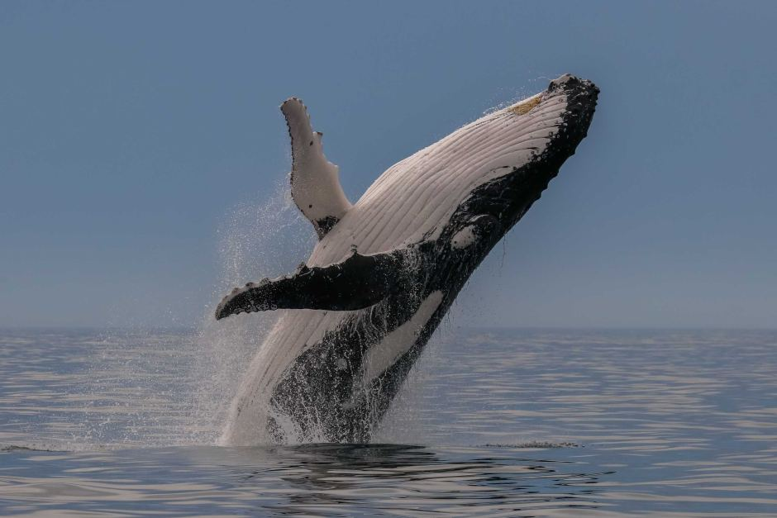Southern Cross University Marine Ecology Research Centre founding director Peter Harrison said whales were moving earlier because their numbers had grown so large.

This season, about 33,000 whales are expected to make the 5,000km migration north from the Antarctic to Queensland's warm tropical waters.

Southern Right whales, blue whales and other species have not been recovering as readily.

"What will happen is the rate of population increase will start to slow and come back to a normal level of growth," he said.

With the recovery of humpbacks also comes other whale species that are associated with humpbacks, such as killer whales.

"We've had quite a lot of reports in the last few weeks of killer whales being seen off the coastline," Ms Crocetti said.

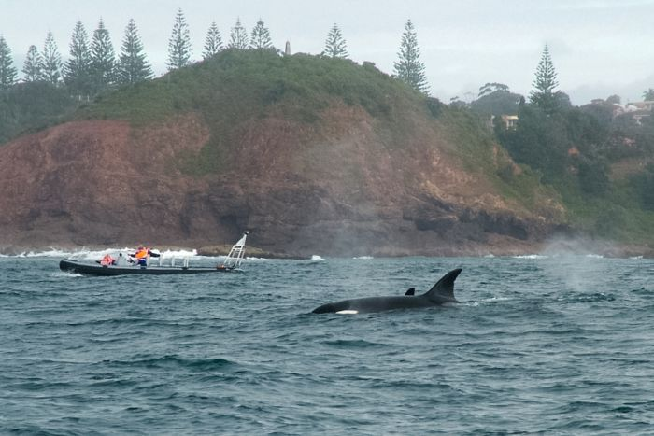[*Killer whales (Supplied: Craig Sargent)*](http://www.abc.net.au/news/2018-05-13/killer-whales/9756166)

"Killer whales have always been around, but in terms of the frequency and the numbers of humpbacks being seen, it certainly does seem to be an increasing trend how many we are observing."

Craig Sargent, a commercial skipper in Port Macquarie, said orcas predominantly liked to chase female whales with their newborns.

"Those females generally close very close to the coastline with their calves, so the orcas have to come in close to find those," he said.

**Montagu Island Barrens and Seals**

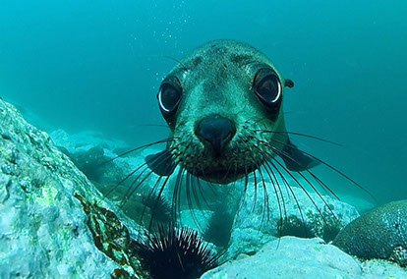[*http://www.marine.org.au/sydney-s-marine-life.html*](http://www.marine.org.au/sydney-s-marine-life.html)

This shot seems to sum up the troubles with expanding urchin plagues on the NSW south coast, where the seal colony at Montague Island is obviously affected. See last issue for more details.

Fast Facts - Montague Island is the largest fur seal colony in NSW with around 2000 seals. Australian fur seals are also found north of Montague Island in places like Jervis Bay and Wollongong.

A batchelor colony can be found on the northern side of the island and visited via charters from Narooma. You can also stay on the island although its very popular.

**Starfish Dieback in Northern Hemisphere**

***Off North America's coasts starfish have perished in large numbers. Recent study shows disease exacerbated by rising temperature is probably the culprit.***

*Source Washington Post;UC Santa Cruz*

Sick seastars are losing arms. Ulcers are opening holes in tissue, and internal organs are oozing out.

[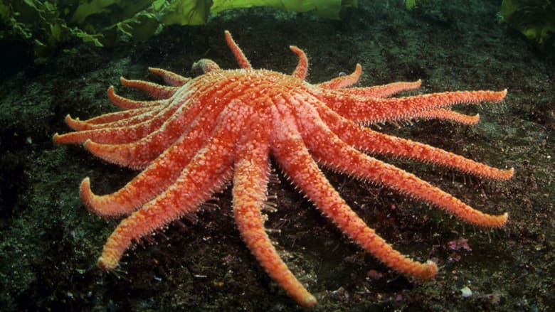](javascript:void(0);)

*A healthy sunflower starfish, British Columbia.*

All along the Pacific coast, since 2014 starfish are experiencing their largest known die-off. A smaller and more isolated Atlantic outbreak has also occurred at points off Rhode Island and Maine.

Seastars have been killed by disease outbreaks several times over the past few decades. But each of those events affected only a single species. The 2014 outbreak killed up to seven species. Mass sea star deaths usually occur in warmer waters south of Santa Barbara in southern California, but not in waters as cool as Puget Sound.

Over the previous several years, local divers noticed that Howe Sound in the northern Unites States West Coast had become almost overpopulated with sunflower starfish, about a dozen per square metre in some areas. When divers returned about a month after sighting infected starfish, "there was 99 per cent mortality."

[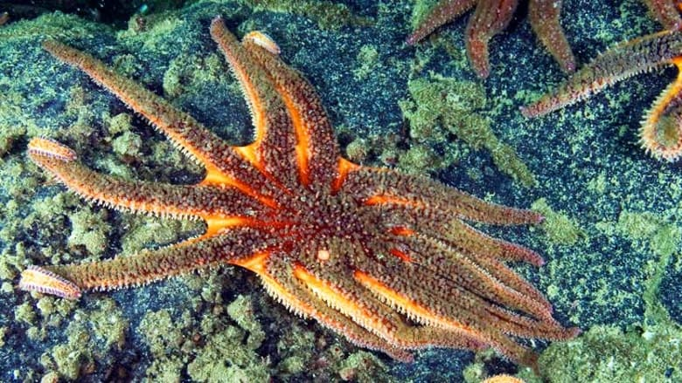](javascript:void(0);)

*A sick sunflower starfish, emaciated appearance and lesions.*

Professor Drew Harvell, of Cornell University said in 2014, "these kinds of events are sentinels of change.” Scientists do know that wasting is happening and “Not knowing is scary”, Harvell said at the time. “If a similar thing were happening to humans, [we…] would commit an army of doctors and scientists to unravelling the mystery”.

He declined to blame climate change or acidic waters or other warming-related issues, saying that without further research that would be just speculation.

Pathogenic bacteria did not seem to be present, although a local aquarium treated its affected sea stars successfully with antibiotics.

The research is in and showed that the cause of the disease is transmissible from one starfish to another and that the disease-causing agent is a microorganism in the virus-size range. The most likely candidate was the sea star-associated densovirus (SSaDV), which was found to be in greater abundance in diseased starfish than in healthy ones.

Researchers also placed sea stars in aquarium tanks. The hotter the tank, the more quickly starfish succumbed to wasting, Harvell said.

“Warmer water temperatures might not have been the catalyst for the disease, but our findings show that if the water hadn’t been so hot that year, the impact would most likely have been less,” said Harvell.

Melissa Miner, a marine biologist at the University of California, Santa Cruz, said sea star populations are still decimated across nearly all of the West Coast.

“We’ve got about nine sites, out of the 70 or so we monitor between Washington, Oregon, and California, where we have seen good recruitment of baby sea stars coming back,” Miner said. But in Southern California, sea star survival has been low. Miner said no sites south of Point Conception are showing much improvement.

“We don’t have the data yet to back this up, but my gut feeling is that we’ll see an increase in mussel cover across many sites—especially in the lower intertidal zones where they are typically controlled by sea stars,” Miner said.

“Alaska is where the action is now,” Harvell said. “They’re experiencing incredible warm temperature anomalies in the northernmost range, and that’s the next region to see how sea stars react there.”

**Awesome Australian Asteroids - The Big and Pretty Tropical Ones**

*Source: Australian Museum, Reef Life Survey,* [*http://portphillipmarinelife.net.au*](http://portphillipmarinelife.net.au)*, Echinoblog*

***By asteroids I mean Class Asteroidea, the sea stars or maybe better known to you as starfish.*** ***I can’t do them all as there are 1600 species worldwide, and plenty in Australia. Many are fascinating shapes and colours and here are just a few.***

**Icon star (*Iconaster longimanu)***

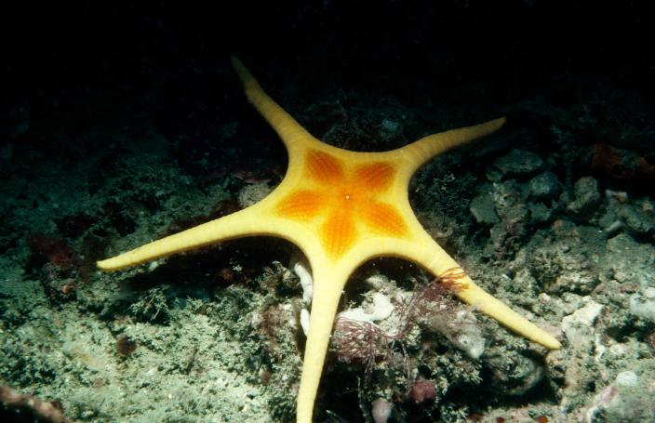

In WA the icon star *Iconaster longimanu* can be yellowish but they come in a variety of colours worldwide. It is found in the west and central Indo-Pacific Ocean including tropical Australia. The genus name comes from the Greek eikon, meaning portrait or image.

**Candycane Star**

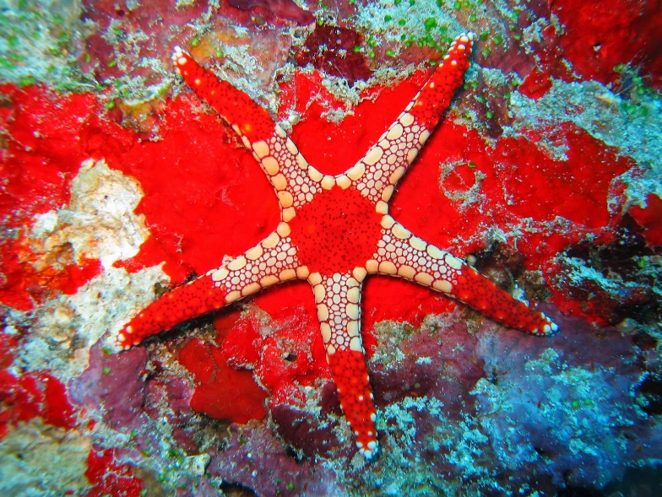

[*The Echinoblog*](http://echinoblog.blogspot.com/2014/07/the-colorful-challenge-of-fromia-indo.html)

*F. monilis* occurs widely throughout the Indo-Pacific and tropical Australia. It goes by many common names, Necklace star, Tiled star, Candycane star, Peppermint star.   This species is often seen in the wild and is a common species in the aquarium trade.

**China and Australian Maritime History**

**Early immigrants**



***The earliest known Chinese immigrant to Australia arrived in 1818, Mak Sai Ying took a farm, and later opened a pub in Sydney. The progressive collapse of China in the mid 19th century accelerated labour migration.***

When convict transportation ceased in the 1840s some grandees imported Chinese servants and labourers. The Australian Agricultural Company based its Port Stephens and Tamworth operations on cheap convict, Aboriginal and indentured labour.

The Chinese Emperor had banned the trade in “coolies” (manual labourers), then tried to regulate it with treaties, but European merchants largely ignored the rules. Some workers may have been kidnapped, the 'sale of pigs' as it was called at the time. The main drivers for migration, then as today, were poverty and civil unrest at home. The period of the Australian gold rush was a time of grinding poverty, lawlessness and oppression in many parts of China, particularly in the districts of Canton (Kwangtung Province).

It is claimed that many ships and crews who had previous experience in the Atlantic slave trade came to transport indentured Chinese labourers. The average voyage from Canton to Melbourne took about 3 months. It became a profitable trade for the ship's masters.

The more Chinese passengers they could fit on board the more money they could make. American and Dutch ships got a reputation for overcrowding. The Chinese were forced to sleep on deck or head-to-toe in bunks in the hold of the ship. Often they were confined below decks because the crews were frightened of Asian people. Due to crowding and confinement, many Chinese died on board or arrived dying of fevers or dysentery. The British Consul of Amoy recorded that on one ship, the lack of food and water had led to the loss of 70 Chinese lives in a few days.

Between 1848 and 1853, over 3,000 Chinese workers on contracts arrived via the Port of Sydney for employment in the NSW countryside. Resistance from white worker to this cheap labour occurred as soon as it arrived.

The activities of these early Chinese labourers aren’t well recorded. Only when the isolation drove them mad did they appear in the records, frequently mentioned as inmates of asylums.

**Gold Rush Chinese**

***The main group of Chinese immigrants that we have reasonably good records about are Chinese miners.***

In 1851, Edward Hargraves discovered a 'grain of gold' in a waterhole near Bathurst. The discovery marked the beginning of the Australian gold rushes. Ophir was home to more than 1000 prospectors just four months after Hargraves discovery. New South Wales yielded 26.4 tonnes (850,000 ounces) of gold in 1852, a fantastic find that electrified the world.

The Victorian authorities, offered a reward for any gold found within 200 miles of Melbourne. In 1851, six months after the New South Wales find, gold was discovered at Ballarat, and later at Bendigo Creek.

In 1852 alone, 370,000 immigrants arrived in Australia and in just two years Victoria’s population had grown from 77,000 to 540,000. The number of new arrivals to Australia was greater than the number of convicts landed in the previous seventy years. The total population trebled from 430,000 in 1851 to 1.7 million in 1871.

The first discoveries in other States were made in Western Australia in the early 1850s (the rich Kalgoorlie and Coolgardie fields were not found until the 1890s); Queensland in 1853; the Northern Territory in 1865; and Tasmania, at Beaconsfield in 1877. Only South Australia failed to produce any gold deposits of significance.

The largest group of foreign workers on the goldfields were the Chinese. In 1861, Chinese immigrants made up 3.3 per cent of the Australian population. These Chinese (38,337 men and only eleven women) were under contract to Chinese and foreign businessmen. In exchange for their passage money, they worked on the goldfields until their debt was paid. The majority of the miners seem to have been the indentured peasant men.

Some Chinese were able to pay their own way. These were often the wealthier city born men who were coming to Australia to be merchants or work in an industry other than gold mining.

The Chinese miners passage was often paid for by the individual’s traditional clan. On arrival in Australia, others from the same clan would usually work and live together under the banner of their association or society. This segregation contributed to the European diggers learning very little about Chinese culture.

The dress and mannerisms of the Chinese also set them apart from the other diggers. Most Chinese men wore their hair in the form of a queue or pigtail, which together with their distinctive clothes often drew derision from intolerant Europeans who has never seen Asian people before.

Religious practices of the Chinese such as Taoism or Buddhism confirmed to many Christian Europeans that the Chinese were heathens. The Chinese were particularly despised for introducing the habit of opium smoking and novel forms of gambling such as fan tan to Victoria.

There were campaigns to oust the Chinese as many felt the Chinese miners would overrun Europeans in the gold fields. The Chinese usually avoided fighting and were pushed off the main workings to work over areas that European miners had already abandoned. They often found rich sums of gold on these leftover claims by working more meticulously, which angered the European diggers even more.

Most made some money, then returned to China. Between 1852 and 1889, there were 40,721 arrivals and 36,049 departures. The miners were encouraged to return by increasingly discriminatory migration laws.

**Rush to Robe**

In 1855, riots on the goldfields caused the Victorian parliament passed the Immigration Restriction Act. This forced Chinese arrivals in Victorian ports to pay a £10 head tax.

It was a ‘stop the boats’ kneejerk reaction that was doomed to failure. Officially Victorian records showed few migrants. However, numbers of Chinese on the Victorian goldfields continued to swell.

The Australian colonies had unpoliced land borders, legislation in one colony could easily be avoided by travelling from another colony by land routes. The ‘people smuggling’ ships just travelled to the goldfields via South Australia. Between 1855 and 1857 thousands of Chinese landed in the Port of Adelaide and Robe near the Victorian border. The agents kept the decision to try landing in Robe completely secret so that the Victorian government could not interfere.

In 17 January 1857, the vessel “Land of Cakes” sailed into Robe’s Guichen Bay without warning, with 264 Chinese passengers. Unfortunately for the diggers, Robe is an exposed and shallow port and the vessel had to anchor offshore.

The captain said to the locals that the Chinese had money and would pay to be taken ashore. Locals with boats were allowed to come out and negotiate their own ferry charges. A local observer reported the plan was to “…, make them pay as much as they could, and even (it is said) take the money by force from some”. The Chinese had no alternative than to pay what was asked, often 8/- to £1. Generally, the seamen unloaded the Chinese passengers’ baggage by throwing it overboard into the tender boats as they drew alongside, sometimes missing with the baggage landing in the sea. Those Chinese who complained were thrown overboard to swim ashore.

From then on Robe was inundated with Chinese miners. The Chinese far outnumbered the 100 to 200 Robe residents. Two schooners from Launceston arrived with more transhipped diggers, the “Cornwall” landed direct from China and several more followed. Three ships arriving on one day on the 27 April 1857 and disembarking 1300 Chinese passengers. To some white Australians it became an “invasion”.

Mistreatment of the Chinese by the ship’s crews got so notorious that the Robe constabulary acted and arrested four sailors for their behaviour when off-loading the 649 passengers and their belongings from the “William Miles”.

Parties of Chinese men would often pay local guides to take them to the goldfields. Sometimes, these guides would abandon the Chinese in the bush, in order to return to Robe and get more money from another group. However, as more and more Chinese undertook this journey it became more organized. Along the way the Chinese established wells and paths through the bush. Many Chinese marks and wells can still be found along this route today. Between 1857 and 1863, 16,262 Chinese landed at Robe.

**Robe Wrecks**

The port was undeveloped and dangerous, a number of ships were lost after being driven onto the limestone reefs in Guichen Bay, Robe. The “Phaeton”, an American ship sailing from Hong Kong on her second voyage and carrying 260 Chinese, was wrecked on 1 February 1857. She arrived in the morning, but mismanagement of her sails and strong winds meant she was driven onto the shore. There was too much surf to land her Chinese passengers in longboats and for a time life-rafts were used. The wind moderated in the evening, by early the next morning everyone had landed safely.

The wreckage was there for some time. Father Tenison Woods, observed the debris of the wreck scattered along the beach. “The greater part of the between cargo was saved - tea, opium, silks and chowchow, a large quantity of linseed oil was also recovered from the lower hold undamaged. I think I collected over 300 pounds custom duties on cargo saved. This wreck damaged the character of the Port but was entirely owing to the fact that the Master did not make use of the service of a pilot when they offered.”

The “Sultana”, journeying from Hong Kong and arriving on 18 March 1857, with her Captain having died on the passage out. The “Sultana” struck the rocks at the base of Cape Dombey on the entrance to Guichen Bay. Due to the heavy weather, the First mate was not able to see any identifying points. All were safely rescued. A bit of an amazing feat if you have ever visited Robe in rough weather.

It was reported that sixteen sailors were drowned when the Dutch Barque, “Koenig Willem II” encountered a southwest gale which grounded the ship on Long Beach on 30 June 1857. Terrific seas washed over her and she was completely wrecked.

Unusually, the crew appeared well led and disciplined. The Chinese passengers were safely unloaded. Twenty-five of the crew left the ship by longboat, but it capsized and only nine men managed to struggle to shore through the breakers. The Captain was later able to drift ashore on a cask after the wind had changed.

For days wreckage and bodies washed ashore, the human remains were in such a decomposed state that it was thought better to bury them on the spot. The sixteen sailors who drowned on the “Koenig Willem II” were buried in coffins in the sand hills. These graves were exposed by the winds 75 years later and had to be re-interred.

Plunderers stole cargo, fittings, and also broke open chests. The wreck was later dismantled, a signal cannon was salvaged is still on display at Royal circus, Robe. Her teak scrolled doors were bought for the construction of the Caledonian Inn in 1859 and can still be seen today.

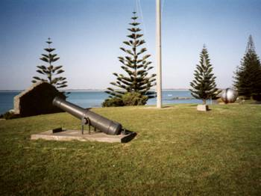Wreck reports give us some idea of the conditions on board. On 15 August 1857, the ship “Manhou” (or Manhow”) was on her way to Robe when she ran on to a reef off Port Willunga, South Australia. She was 114 days out from Hong Kong with 338 Chinese and manned by Malay sailors. She wasn’t a happy ship and an eye witness account shows how poor conditions could be,

*“Most of the passengers and crew had by this time landed, but about one hundred remained on board, and, from their actions, seemed determined to appropriate to themselves anything in the shape of plunder which they could get hold of. The chief officer was the only officer remaining on board, and he had entirely lost all control over the actions of the crew, who hung sullenly about the decks, apparently undetermined how to proceed or what course to pursue. Upon going over the ill-fated ship's gangway, a more disgusting and filthy scene could not be imagined ; everything seemed in disorder, and the nasal organs were saluted with a most villainous stench arising from putrid vegetable matter which lay about the decks in all directions; and on going below the scene, if possible, was much worse, as it would seem that the celestials on their exodus had left behind them all the refuse, provisions, rags, and other matters which together caused the intolerable stench. Her passengers were carried on three decks, and through them all the same foetid, sickening smell prevailed”.*

She was a huge Portuguese ship of 1115 tons. Later refloated, she was undamaged but laid up for "survey". This obviously revealed other serious defects and she was broken up. She was uninsured, further suggesting the "Manhou" was a rotten old hulk in poor condition. The Chinese made it to Robe in another vessel.

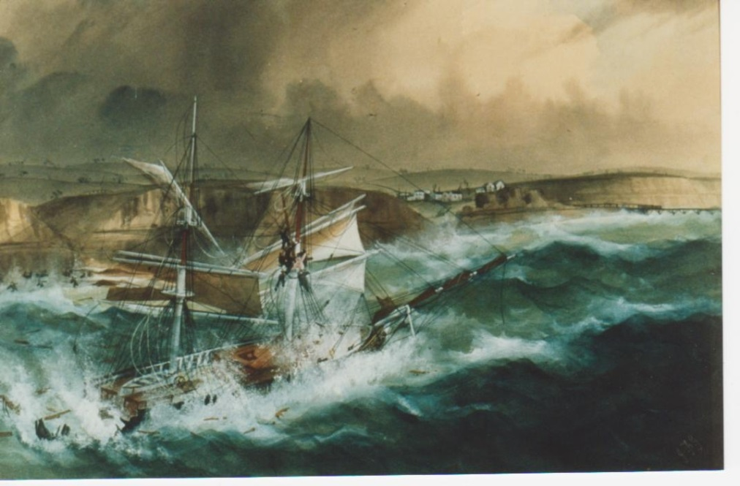

**Reef Teach**

***Up in Cairns? Then drop in for a quick overview of the ecology of the reef. It’s worth it.***

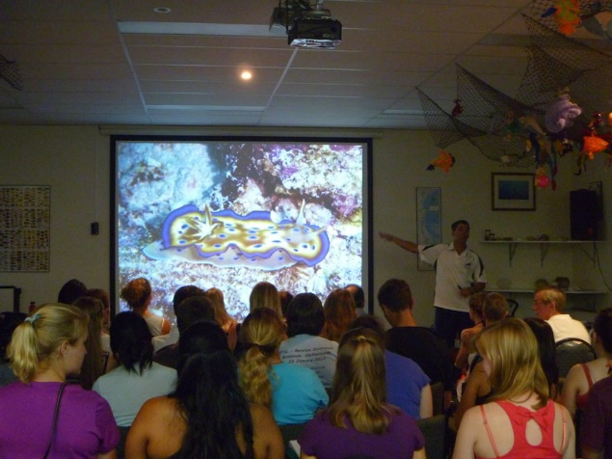

*Photo per Nomadsworld*

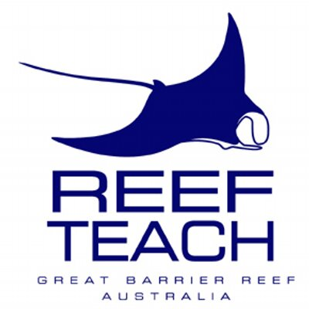Late at night in the rooms above a quiet Cairns shopping arcade a group of tourists have gathered for a 2 hour reef course. After paying over the quite reasonable fee of $23 for adults, they then receive a detailed two hour insight in to the reef and how it works.

The program started in 1992 and I understand that Reef Teach has a relationship with the cruise operators on the reef. The speaker at our presentation was a trained marine biologist who was working on the tourist boats to make ends meet.

They have been doing well, able to afford rented rooms and one salaried staff member. They were disappointed about their small size, but hey, check out some of the struggling NGOs in temperate Australia.

The course had nice fish pictures and the usual stories about the sex lives of strange animals, but also had more detailed information on reef systems.

It also debunked lots of myths, including that the GBR looks like all the more florid tourist brochures in the spots you are likely to visit on a day cruise. They said that the newspaper claims that the reef was “dead” are also false, and that the reef is overall in good shape and damage in the Cairns sector from the last heat wave is only about 15%. They pilloried doomsayers (especially in Europe where the news is heavily sensationalised) who have caused a big drop in tourist visitor numbers to Cairns this year.

More controversially for me (*yes, I embarrassingly argued with them – I think my teenager has just got over the shock)* they did not highlight the 65% damage in the northern sector above Cooktown, instead smearing the damage statistics across the entire reef and averaging it. This is also misleading in my opinion. We agreed in the end that there is a fine balance between being unduly alarmist and recognising that the reef is vulnerable to some pretty serious longer-term threats.

The speaker was also blaming politicians and was a bit dark on other local environment groups who wouldn’t agree to fold in with their efforts. They were also critical of the AIMS GBR surveys as not being enough, again check out the temperate monitoring. No mention of the blame attached to the participants, including us, who had all arrived in our CO2 producing cars. Of course, I needed to get my moneys worth and also argued about that *(don’t you just hate those loud know alls in the class!).*

Anyway, it was an excellent program and well worth doing when you get there. Get in to them, they enjoy an argument – Ok they were tolerant - on second thoughts, maybe don’t. [www.reefteach.com.au](http://www.reefteach.com.au)

# **Bait businesses hit by disease**

***The discovery of white spot disease (WSD) in northern Moreton Bay has caused a two-year restriction on the movement of ocean-caught green prawns, yabbies and marine worms between Caloundra and the NSW border .***

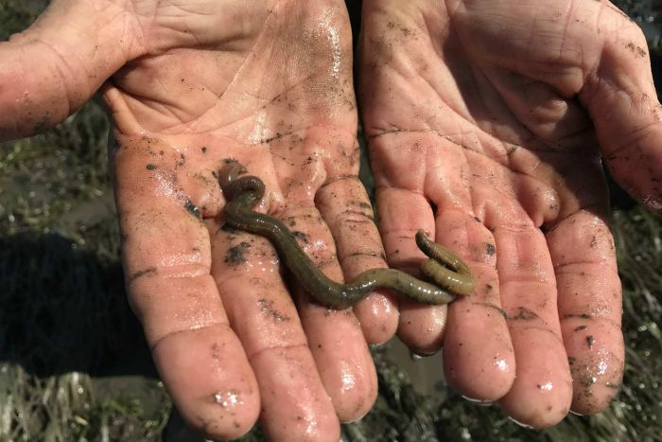A ban on the movement of a bloodworm, prized by Sydney's recreational fishers, is crippling bait businesses in south-east Queensland.

The once-lucrative business, which he runs on the mud flats of Moreton Bay now has an uncertain future.

WSD, also forced seven Logan prawn farms to de-stock, was still present in wild prawns in northern Moreton Bay. The virus is not harmful to humans.

The Federal Government testing regime of green imported prawns has been tightened but the Agriculture and Fisheries department has not confirmed how it entered the country.

The commercial fishers said Moreton Bay provided the only reliable commercial source of bloodworms in Australia and they were yet to see a single worm affected by the virus.

"Unfortunately white spot is not going away. From the latest surveys they've said it's still here. So we just don't look like we've got a future in the bloodworm industry."

The cost of WSD to Queensland's commercial prawn farmers was softened by a $20 million compensation package from the Federal Government. But there was no such plan for compensation for the live bait industry.

The bloodworm is typically found on the bottom of shallow marine waters. April, 2018.

A Biosecurity Queensland spokesperson said a number of bloodworms from within the white spot disease movement restriction area were tested. None were infected with white spot.

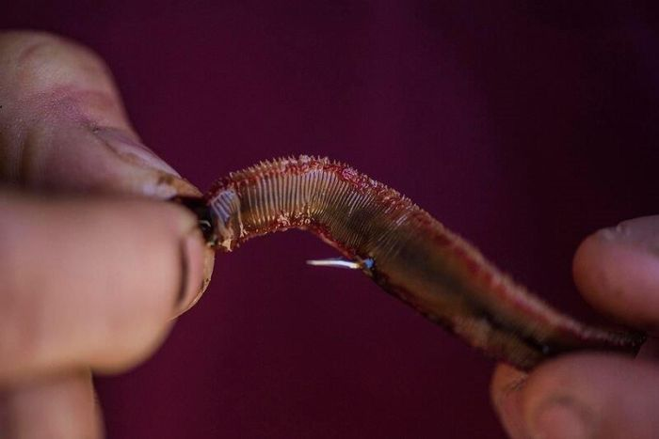

 "Bloodworms pose a significant risk for the spread of the disease as they are collected and distributed nationally for the sole purpose of being used as bait. Nationally endorsed scientific literature has shown that polychaete worms, including bloodworms, can carry white spot syndrome virus,” the spokesperson said.

# **Sea Hares Have Genetic Memory**

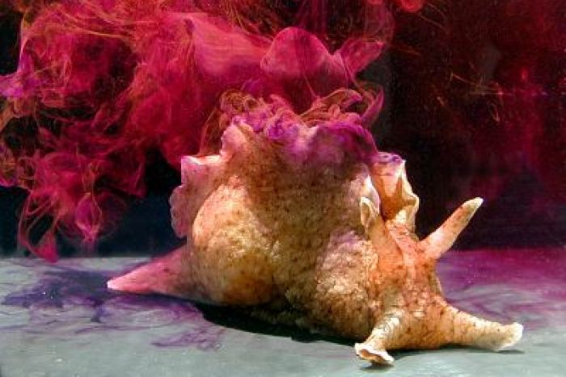

*Sea hares emit ink to confuse predators but they have other capabilities*

**Scientists transplant sea hare memories.**

Ok what exactly does a sea hare remember and how can you transplant them?

Researchers are using a series of mild electric shocks to train sea hares to associate a tap with potential danger and shrink up [I would too if the tap was the guy giving me shocks]

Researchers then injected ribonucleic acid (RNA) from the trained [tortured] snails into the second control group.

All seven of the snails that received the new RNA then showed the same defensive behaviour.

The findings of the study could affect our understanding of memory. Scientists have long believed memories were stored in the arrangement of synapses, the connections between neurons. "If memories were stored at synapses, there is no way our experiment would have worked."

He said cellular and molecular processes of humans and snails were very similar.

Professor Glanzman said in future it might be possible to awaken and restore memories that have gone dormant in the early stages of Alzheimer's disease, or ameliorate the effects of post-traumatic stress disorder.

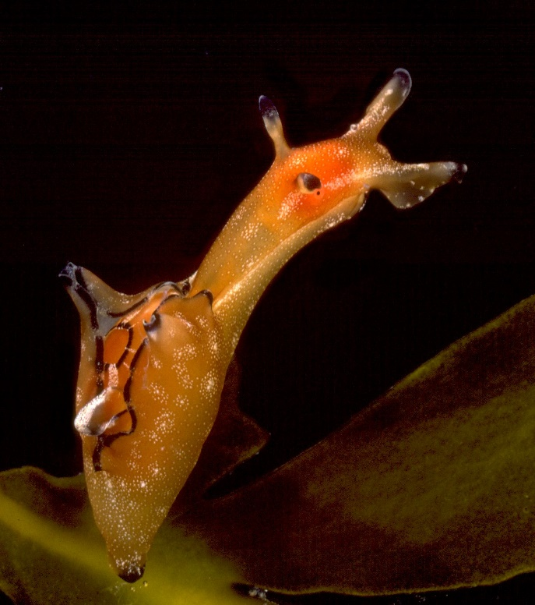The Sea Hares, consist of 9 genera: Aplysia, Bursatella, Dolabella, Dolabrifera, Notarchus, Petalifera, Phyllaplysia, Stylocheilus and Syphonota.

They range in size from species growing less than 2 cm, to large species which reach over 70 cm in length.

They come and go at different times but are easy to find in rock pools when they are abundant.

**Urchin Diseases**

***A study of the urchins of Bare Island near Sydney shows disease may be spreading through urchin populations***

*Source: New disease outbreak affects two dominant sea urchin species associated with Australian temperate reefs, Michael Sweet et al. 2016; Weekend Australian*

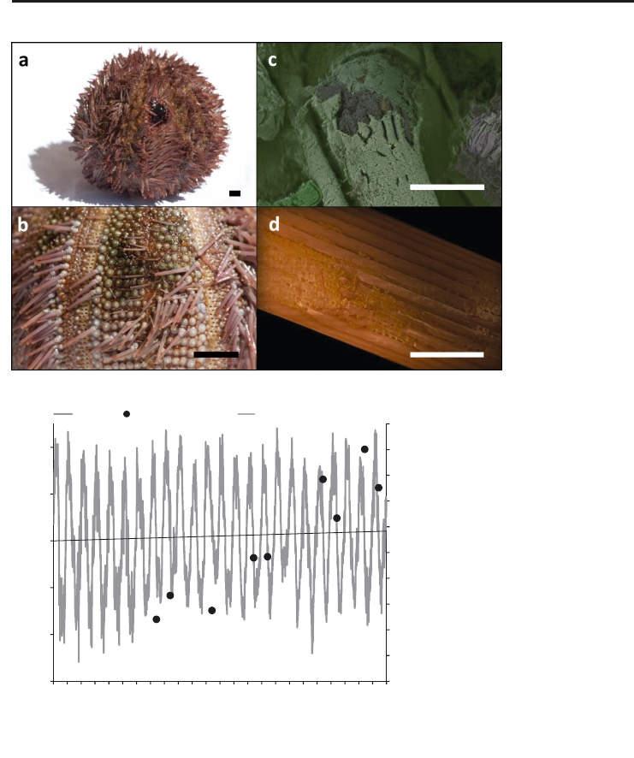Diseases in marine animals are reported to be increasing worldwide and climate change and other anthropogenic stresses have been named as a likely driver. Mean sea temperature is rising by 0.2°C every decade. Oceanic acidity has increased from 8.2 to 8.1 since the industrial revolution.

Some authors state that overall urchins have been in decline in the past half century due to disease, despite news of massive outbreaks in many areas. Urchins populations fluctuate ‘normally’ with changes to nutrient supply, the number and type of predators, storms and increases in incidence of diseases.

Australia is a well-known diversity hotspot for sea urchins, in particular the temperate waters off the south-eastern coast. Two of the more abundant species in these ecosystems are the native or purple urchin *Heliocidaris erythrogramma* and *Holopneustes purpurascens* an urchin that climbs up stalks of seaweed*.*

During surveys from 1996-2013, a previously unreported disease was noted after unusually big aggregations of *H. erythrogramma* occurred. Diseased individuals showed distinctive dark slimy lesions on the exterior and a loss of spines around the lesion. The number of individuals displaying lesions have increased as sea surface temperature (SST) have increased. Urchins also get sicker faster as sea temperature rises.

The pathogen was *Vibrio anguillarum.* Vibrios are already known to be responsible for diseases associated with 2 other urchin species, as well as eels, oysters, fish and lobsters. This disease has been associated with mass mortalities in California, the Mediterranean coast of France. This pathogen has also been reported as existing in apparently healthy populations of sea urchins.

It has got a name, “Bald sea urchin disease”, and it might be seen as a good thing by people noticing urchin barrens in some areas, but it doesn’t seem to attack the ‘bad urchins’, the main barrens forming species *Centrostephanus Rogersii*.

Urchins are usually very resilient to disease according to scientist Sham Nair, “They have huge immune diversity" so vast it leaves researchers "spellbound". The sea urchin has 10 times as many SRCR genes as vertebrates. SRCR genes produce proteins that home in on microbes and they have systems to eject pathogens. Sea urchins also have 222 specialised immune proteins, in contrast to a mere 10 in people. It is hoped that some of these can be developed as medicines.

I note little further evidence of mass urchin mortality since the survey dives performed for this study, and suspect this is a ‘watch this space’ message rather than a present threat to the viability of these species.

**Great Pacific Garbage Patch is Bigger than thought**

*Source: The Ocean Cleanup Foundation*

[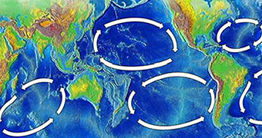](http://www.abc.net.au/news/science/2017-02-27/plastic-and-plastic-waste-explained/8301316)

***Ocean currents create large eddies in some places in the mid-ocean known as gyres. These are collection points for debris floating on the ocean surface. The gyres in the northern hemisphere are particularly full of plastics and the largest is in the North Pacific.***

New surveys show that this Great Pacific Garbage Patch contains up to 16 times more waste than previous surveys were able to detect. " we decided … to conduct an aerial expedition above the patch. We collected about 7,000 images and that helped us to calculate the contribution of larger debris such as ghost nets."

In 2015 and 2016 surveys there were an estimated 1.8 trillion pieces of plastic floating in the patch. The research included microplastics less than 5mm, that are only about 8% of the waste by mass. The bulk of it is larger items like fishing nets. Almost half the larger debris they identified was commercial fishing gear including nets and fish aggregation devices. It is estimated that 78,200 tonnes of plastic waste are packed into an area almost the size of Queensland. [I find those measures meaningless though, that’s 13000 African plains elephant, the contents of 10000 large garbage trucks, about 1.5 times the weight of the Sydney harbour bridge].

Lead researcher Laurent Lebreton said "We show that plastic concentration has been increasing exponentially since the 1970s for different reasons," said Dr Lebreton.

The growth was boosted by debris washed out to sea during the Japanese tsunami in 2011. "We correlated that with our model and we looked at estimates from the Japanese Government in terms of how much they think was washed to sea that day… and we predict that about 10-20 per cent of the materials post-2011 in the larger size class came from the tsunami."

Research scientist Dr Denise Hardesty from the CSIRO said it wasn't surprising the survey produced a much larger size estimate of the garbage patch, given the different research methods used. "Ghost nets will weigh so much more than all those little tiny bits and pieces and fragments." But she says that the new research is still cause for concern.

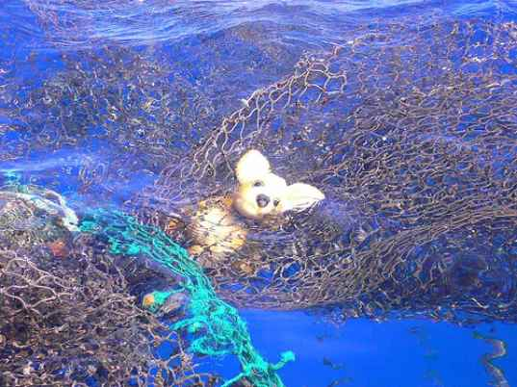"We need to deal with this before it enters the ocean rather than when it's out in the middle of the ocean." Plastic circulating in the garbage patch does eventually get "kicked out" and washes up on coastline, Dr Hardesty said. But right now we are feeding waste in at a much higher rate than it can be expelled.

**Snail Plagues**

***So big things some in little packages? The Drupella snail (*D. cornus) *is about the most innocuous little thing you could think of. They are often found washed up on tropical beaches and I have a fistful of them at home in my shell collection. One of the reasons why they are so easy to find is that they multiply faster than the U.S. national debt.***

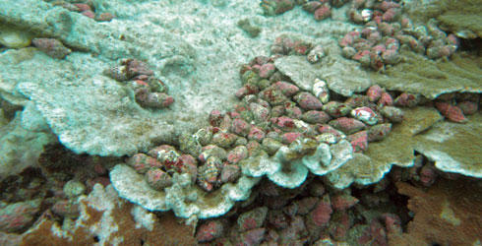

This snail is found in the Indo-West Pacific, from the east coast of Africa to Hawaii and Guam, and also the Red Sea.

Since the early 1980s, outbreaks of *Drupella* snails have been reported in Ningaloo Reef in Western Australia, Izu Islands in southern Japan, and in Eilat and the Gulf of Aqaba in the northern Red Sea. Between the mid 1980s and early 1990s, the feeding activity resulted in massive coral damage along at least 100 km of Ningaloo with coral mortality approaching 100% at some areas. The density of, the area and severity of associated coral damage and longevity of the outbreak itself that occurred at Ningaloo MP during this event was on a greater scale than recorded on other reefs elsewhere in the world to date. During plagues up to 175 individuals per square metre can be found.

At the time, the effects of *Drupella* snails was comparable to crown of thorns starfish. However, unlike the starfish, *Drupella* snails are not immune to the stinging cells - nematocysts - of live coral. They avoid contact with live coral tissue, preferring to perch on dead coral and feed on the live tissue by extending a proboscis (mouth part). This means that corals that have been previously damaged by other predators, severe storms or climate change are more prone to predation by *Drupella* snails.

However, scientists believe that predation by *Drupella* is not a major threat to corals, compared to other threats such as over-fishing, habitat destruction, and coastal run-off.

Stinging corals are awkward to eat, so drupella snails are choosy. Faster growing *Acropora* staghorn coral and surf loving *Stylophora* cats paw coralattract the most snails. A few will even tackle huge *porites* brain coral. *Acropora* sp*.* and *Stylophora* sp. may contain chemicals that attract the snails. Similar coral species like *Pocillopora* or *Seratophora* are much less likely to be eaten, although both of them are highly branching and should provide enough food and shelter. Their prey selection might lead to changes in reef community structure, with significant decreases in the numbers of the preferred coral prey.

They also get active and hungry in warm conditions. The grazing rates of drupella were influenced by seawater temperature, increasing by five times at 30ºC compared with 18ºC. Drupella cornus then multiply. They can produce more than 150 thousand plankton veligers one month after spawning. These little larvae swim to their coral prey and settle.

They thrive on damaged or stressed reef. A field survey of D. cornus in the Gulf of Aqaba showed that numbers were higher in industrial areas when compared with reserve areas. Increased run-off, over fishing of predators such as triggerfish and increased reef damage, and natural causes have been suggested to explain outbreaks of Drupella spp.

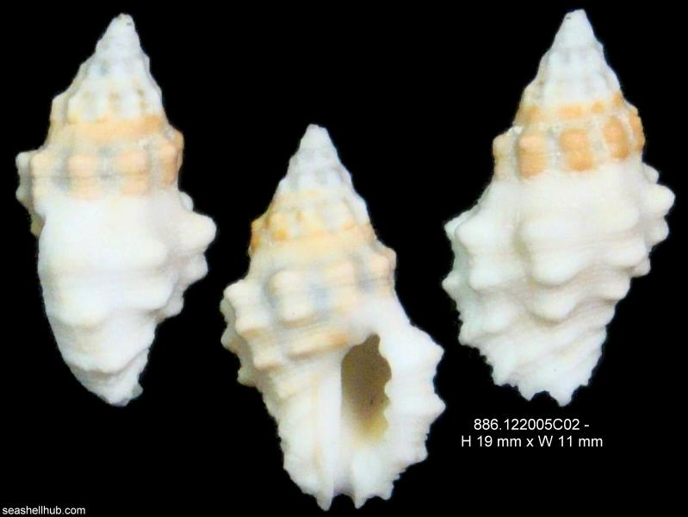Drupella is well equipped to profit from rising sea temperatures and loves the types of corals that are easily damaged in the warm shallows. They can compound the damage caused by other disturbances.

Drupella snails aren’t evil. Their shells are even quite cute. They simply take advantage of mayhem when we alter the marine environment. The normal feeding activities of D. cornus don’t cause significant damage to corals, but when outbreaks occur ecosystem changes might result, especially when this is added to other stressors such as bleaching, diseases and pollution.

**WA/SA Special Fish - Eel Snake blenny**

***This fish is endemic to South Australia and Western Australia, from Victor Harbor and Kangaroo Island (South Australia) to the Recherche Archipelago (Western Australia).***

The Eel snake blenny inhabits quiet bays and estuaries, sheltering amongst seagrass leaves, roots, and decaying vegetation, in depths to 13 m. The fish is 13 cm long and feeds on small invertebrates. It doesn’t lay eggs like most fish but is viviparous - with internal fertilisation and birth of live young.

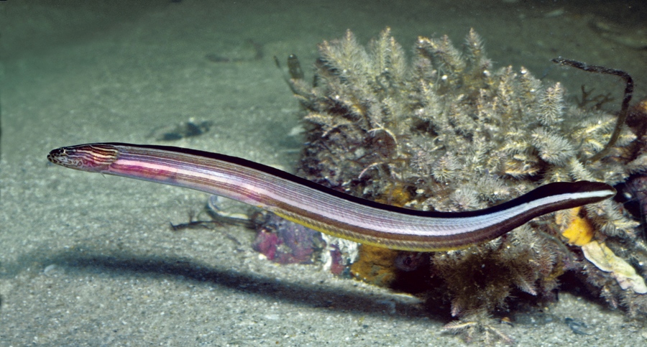

Eel Snake Blenny, Peronedys anguillaris. Source: Rudie H. Kuiter

**Visit Exmouth/Ningaloo Western Australia**

***Ningaloo is famous for its whale shark encounters, but it’s a lot more than that. The Ningaloo Marine Park protects one of the world’s longest barrier reefs.***

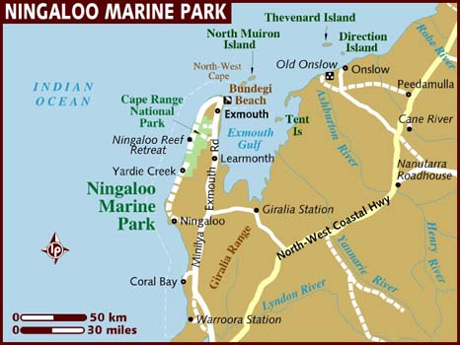

Ningaloo Reef extends for 260km along the coast of Western Australia. Being the nearest point on the continent to the Continental Shelf it offers a huge variety of fish and other marine life. The diving here ranges from shallow to 35m and the reef structures are all hard coral.

The outer reef and passages offer remote and challenging diving on an exposed coast. There are big fish and big wrecks in some tricky spots. Inside the outer reef there are large coral gardens in slightly less challenging conditions, while along the shore there are plenty of camping spots with long spectacular beaches and plenty of shallow, sheltered places for snorkelling and shore diving. Most visitors are happy swimming or snorkelling in the protected shallows.

**When to go**

IMHO June is the time to visit, when all the whales and whale sharks and Mantas are in the area and the daytime temperatures are bearable. It’s also peak tourist season so book early. The whale shark is said to prefer waters of surface temperature 21-26 degrees centigrade, in areas where there are upwellings of nutrient rich colder water. These conditions favour blooms of plankton on which the sharks feed.

|  |  |  |  |  |  |
| --- | --- | --- | --- | --- | --- |
| Wild Life activities in the Ningaloo Marine Park | | | | | |
| Month | What's about | Temperature | | | Water temp. |
| April | Whale sharks (another site says March- July). Manta rays. Coral spawning | Low 30C | | | 22C |
| May | [Whale sharks](http://www.coralbay.org/whalesk.htm). Manta rays (another site says June/July) | Low 30C | | 22C | |
| June | [Humpback whales](http://www.coralbay.org/whales.htm)start their annual migration north to their breeding grounds. | Mid to high 20C | 19-22C | | |
| July | [Humpback whales](http://www.coralbay.org/whales.htm) migrating north (another site says June-Aug). Bait fish schools accumulate outside the reef. Sailfish appear outside the reef. | Mid to high 20C | 19-22C | | |
| August | Humpback whales and Sailfish | Mid to high 20C | 19-22C | | |

***Where to Stay***

***Exmouth (near the airport)***

You will probably arrive through Exmouth. Exmouth is mainly a secure naval base but there is fuel, a caravan park, tourist accommodation, and boat ramp at Exmouth marina. This is close to the Cape Range attractions but more distant from the sheltered reef locations.

***Coral Bay (155 kms from Exmouth)***

The main facilities are at Coral Bay where there is fuel, a caravan park, tourist accommodation, public phone, boat ramp and food.

are many tours on offer in Coral Bay, including glass bottom boat tours, diving tours, manta ray snorkel tours, whale watching tours, whale shark snorkel tours, quad bike tours and sailing tours.

Coral Bay has limited accommodation, therefore booking well ahead is essential during the peak season of March-November.

***Bush Camping***

Seaside resort or camping at Ningaloo marine park. There is ‘bush’ camping all down the coast (mostly with fees payable to the private landowner).

**Boat Launch sites**

Outside the main villages, there are other ramps for water activities at Tantabiddi, Bundegi as well as some beach launching sites. Rather than hauling a boat around Australia across some of the world’s loneliest spots for a trailer breakdown, most tourists rely on local charter operators.

*[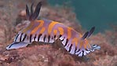](http://underwater.com.au/content/6633/nudibranch.jpg)*

**Diving Sites of Ningaloo**

There are many sites, not all can be dived at all times of the year and are heavily dependent on wind, swell, currents and tides. However, due to Exmouth's location on the North West Cape peninsula at least one side is partially protected from the prevailing conditions. The shallow reef lagoon is often sheltered. Here as everywhere, the operators have favourite closer locations, or as one traveller put it,

“Unfortunately, even if conditions are conducive to diving the more remote areas, often operators won't deviate from their local 'cattle truck run' due to expenses, logistics and time”.

First time visitors will find plenty to do, but if you want to really travel widely across the area negotiate a private, customised charter.

***Exmouth - Lighthouse Bay***

Referred to as 'Local Reef Diving' by operators, is a 30 min boat trip from the boat *[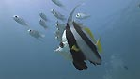](http://underwater.com.au/content/6633/bannerfish.jpg)*ramp at Bundegi Beach. This is considered the 'bread and butter' diving of Exmouth due to close proximity, reliable marine life sightings, numerous dive sites, and shallow depths.

Dive sites include 'Blizzard Ridge', the Labyrinth, Gulliver's, Eldorado's and the Fish Hole. These are huge limestone outcrops isolated on the sand, attracting thousands of fish of all sizes and regular appearances of sea snakes, turtles, manta rays, sharks and colourful nudibranchs.  
Most of the dive sites here are in an easy 8-15m depth, and allow for long, relaxing dives and great light and colour.

***Non-Shop Commentary on Bundegi Reef***

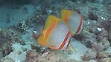“Bundegi Reef is the "get out of jail card' for local operators, although ask any Exmouth locals and dive crew and they will tell you that it is one of THE most underrated dive sites of Exmouth and no less spectacular that the Eastern sites on the Muiron Islands. Bundegi reef is recognised by coral reef scientists as having one of the highest coral recruitment rates in the world and has been deemed a productivity hotspot. This is hardly surprising as it is nestled between the nutrient rich Exmouth Gulf, (the lifeblood of the area) and the Ningaloo Reef. The dives here a shallow and need to be timed for slack tide or executed as drifts. When category five cyclone Vance hit Exmouth Gulf in 1999, a lot of the coral here died either as a direct result of being pounded by storm surge or being smothered by the turbid water and silt. A lot of this damage is still visible, however the reef is recovering at an impressive rate and it is fascinating to observe the new corals reaching up through skeletons of dead coral, determined to return Bundegi reef to its former glory. The larger boulder corals which survived the cyclone are like huge apartment blocks, filled with fish and animals at every level. Bundegi reef is "busy" with fish. Reef sharks, turtles, sweetlips, coral trout and Spanish flag can be found loitering amongst the bommies and manta rays will glide past later in the year.

Bottom scratchers enjoy diving Bundegi reef due to never ending species of nudi branchs which crawl past as well as triton shells, flatworms, sponge crabs and other critters. Although night diving isn't offered by most operators in Exmouth, Bundegi Reef offer's some special after dark action- most notably the coral spawning which occurs, seven to ten days after the first full moon in March.”

***Exmouth Navy Pier***

12-17M

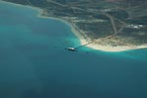The 300M long Navy pier was built in the 1960’s by the U.S. government and lies inside a restricted area that can only be visited with a permit. Only one shop has permission to take groups and they can only perform guided shore dives. [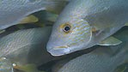](http://underwater.com.au/content/6633/sweetlips.jpg)The entry may be from the platform or from the beach depending on the work schedule for repairs and upgrades to the pier. It must be dived during slack water. Groups are a maximum of 8 divers per guide so you need to book a week in advance so they can sort out the navy paperwork which is pretty meticulous. Visibility can be variable and drops after strong winds, but is often about 10M or more. The pylons have plenty of colourful filter-feeding growth and heaps of fish, wobbegong sharks, white tip reef sharks, large cod and groper, lion fish, angler fish, stone fish, scorpion fish, frog fish, moray eels, trevally, barracuda, batfish, bannerfish, crocodilefish, butterflyfish, angelfish, queenfish, perch, snapper and coral trout. All the fish are huge due to the zero fishing pressure and this is the payoff for all that effort. You may have a long day with an early pick up due to tides and the unusually long preparation time. A night dive is also recommended.

*More Commentary on* diving the navy pier

“a little bit expensive, the water temp was 23 degrees. The marine life was amazing. 8 white tip reef sharks, a grey nurse shark, a wobbegong, trevallies everywhere, a massive 300kg grouper, nudis, etc”

*Another commentary Exmouth Navy Pier*

The world famous Navy Pier stretches out into Exmouth Gulf and is next door to Bundegi Reef. The Pier has been rated as one of the top ten dive sites in the Australia and one of the top ten Pier dives in the world- and with good reason! The pier has been closed to fishing for a number of years all the life has been left to grow and breed. As a result, the water beneath the Pier is filled to the brim with fish of all sizes and species.

The max depth is around 10m, providing an easy dive and allowing plenty of bottom time. Entries are from the shore or a giant stride from a platform and dives need to be made during the window of slack tide. Due to tidal movement, visibility on the Pier is rarely exceptional, however the trade of is that the sheer abundance of life requires the diver to look little more than 5m for the next breathtaking sight!

Despite low visibility the dive is easy to navigate and is a photographer's dream, with life everywhere and seemingly unafraid of divers. Huge, curious estuarine cod follow the groups of divers over the top of wobbegong and white tip sharks sleeping on the bottom. Sea snakes wind through the coral encrusted pylons and frog fish stare out from the discarded piping which litters the sea floor. Thousands of trevally swim laps close to the surface and elegant lionfish hand suspended in the water column and most divers exit the pier completely exhilarated and determined to dive it again. Night dives on the pier are equally amazing and are offered to advanced divers when tides are conducive.

***Ningaloo lagoon***

The lagoon has a maximum depth of 9m and has provides great snorkelling opportunities, however the advantage of being on SCUBA and being able to remain submerged allows for excellent light filled photos with brilliant colour. Life includes chevron barracuda, lagoon rays, schools of puffer fish, colourful reef fish and even a dugong slinking by.

***Exposed West Coast of Ningaloo***

The West coast is where the actual exposed; fringing reef runs parallels to the beaches, whose shores are protected by a shallow inner lagoon. The Whale Sharks congregate on the west coast, feeding on the nutrient rich waters during 'the season' and there are opportunities to dive both inside and outside of the lagoon.

The deeper water outside the back of the reef has some interesting country, ranging from steep walls to huge overhangs and swim thrus in15- 25. At certain times of the year, these swim thrus fill up with glass fish creating 'bait cracks'. The bait cracks attract all types of pelagic fish, schools of Trevally, Rankin cod, sharks, snapper and bull rays. The outcrops are also permanent homes to huge sea turtles, friendly potato cod and lazy wobbegong sharks.

Unfortunately big, constant swells limit the number of clear days on the west coast, but there is some deeper ground that has more reliable visibility although notable less life.

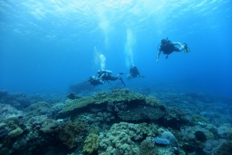***Muiron Islands* (per Dive Ningaloo shop information)**

These two islands are located only 9nm north of Exmouth. The Muirons are different to the west side of the peninsular in terms of coral life, even although they are located close by. Here there is an abundance of soft corals, gorgonians, and sponges fringing the islands, seen no-where else on the Ningaloo. Soft corals provide beautiful colours and movement in the water.  The islands also boast some incredible fish life, turtles, octopus, sharks and mantas to inhabit it.  Many of the sites also have swim throughs, filled with glass fish and cod. Our favourite site is a beautiful drift dive between the islands. If nudibranchs are your thing, then you’ll love these dives!  This is the Ningaloo at its best.

The Muiron Islands are also fantastic for snorkelling with lots of reef and protected spots.

**Non – dive shop commentary on Muirons**

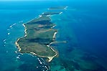“Pronounced 'Myoo- rons', these Islands are recognised as the most Northern boundary of the Ningaloo Marine Park.

The Islands take around 50mins to reach from Exmouth and the crossing is not always appealing to divers susceptible to seasickness. Once at the Islands, there is usually somewhere sheltered to dive, however conditions are unpredictable and heavily affected by wind, swell and current. Visibility is rarely exceptional at the islands, due to the constant movement and the powder fine sand of the seafloor being constantly tossed into the water column.

Seasickness and poor visibility aside, the Islands do provide an awesome opportunity to explore some wild country. The strong currents make this an ideal place for soft corals and sponges to live and the colourful gardens stretch out as far as football fields. There are swim thrus that wind from 5m to 12m and some BIG pelagics! Kamikaze mackerel and tuna fly overhead, curious manta rays. Lazy nurse sharks rest in caves and BIG cod appear from nowhere.

The Islands are a place for BIG things and the best piece of advice here is to look up! Unfortunately, the Muiron Islands have experienced significant fishing pressure over the years and stories and huge cod feeding frenzies and bommies choc full of jumbo crayfish are becoming harder to believe. Unfortunately, this is also the reason why local diving operators have declined marine park management offers to install moorings at heavily dived locations. The reasoning is that for the small amount of coral destroyed by anchor damage, leaving the dive sites unmarked will minimise the loss of fish life from the area.”

**Sharks love jazz**

***Sharks can be taught to recognise jazz from classical music- when rewarded with food***

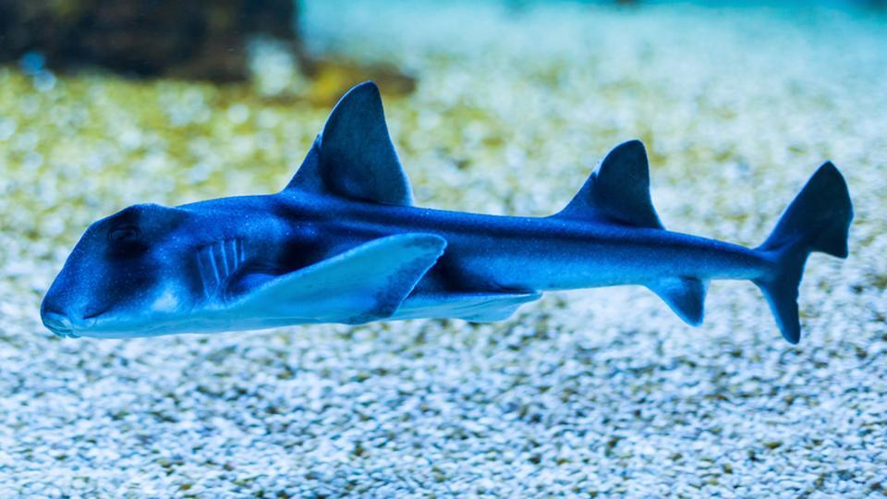Researchers trained juvenile Port Jackson sharks to swim over to where jazz was playing, to receive food. Vila Pouca added: “Sharks are generally underestimated when it comes to learning abilities – most people see them as mindless, instinctive animals. However, they have really big brains and are obviously much smarter than we give them credit for.”

Then classical music was added, which they could detect as not the same music, “It was obvious that the sharks knew that they had to do something when the classical music was played, but they couldn’t figure out that they had to go to a different location,” said researcher Culum Brown.

It is thought that sharks learn to take food thrown from tourist boats or b ycage-diving expeditions – the study shows that they can learn these associations quickly.

# **Great Barrier Reef to get $500m**

**A $500 million package for the Great Barrier Reef has been announced by the Federal Government.**

[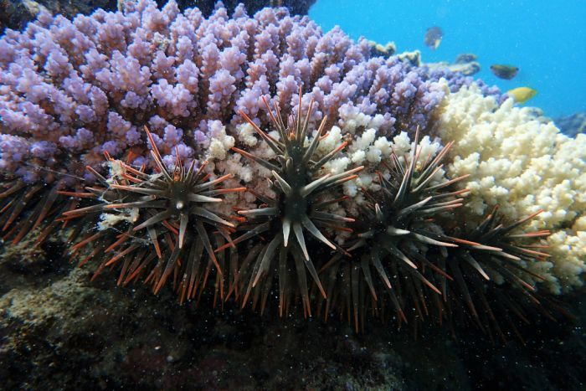](http://www.abc.net.au/news/2018-01-05/crown-of-thorns-starfish/9305686)The funding will go towards improving water quality, tackling the crown-of-thorns starfish, and expanding reef restoration.

It will also help develop coral that is more resistant to high temperatures and light stress.

The government said the funding represented the single largest investment for reef conservation and management in Australia's history.

## $500m funding breakdown

* $201m: Improving water quality with changed farming practices such as reduced fertiliser use.
* $100m: Reef restoration and funding science that supports reef resilience and adaptation.
* $58m: Fight against the coral-eating crown-of-thorns starfish.
* $45m: Community engagement such as Indigenous traditional knowledge for sea country management.
* $40m: Enhancing reef health monitoring and reporting.
* $56m: The Great Barrier Reef Marine Park Authority and the Department of the Environment and Energy to expand environmental management and compliance operations.

Chairman of the Great Barrier Reef Foundation Dr John Schubert said the investment brought real solutions within reach.

Mr Schubert said the reef was under enormous threat from climate change and "we must all work together to do everything possible to achieve the Paris Agreement".

"But while the world works to tackle climate change on a global scale, there are many things we can and must do to build the resilience of the Great Barrier Reef right now," he said.

Opposition Leader Tanya Plibersek welcomed the extra funding for the Great Barrier Reef but said the Government needed to focus on climate change.

"The biggest threat to the reef is climate change and we've got a government that continues to be hopelessly unable to take serious action on climate change."

Australian Marine Conservation Society campaign director Imogen Zethoven said the money for problems like water quality and crown-of-thorns starfish plagues were welcome.

"But there's a huge missing piece in the puzzle and that is a dramatically significant response to climate change.

# **Damaged coral reefs are going quiet**

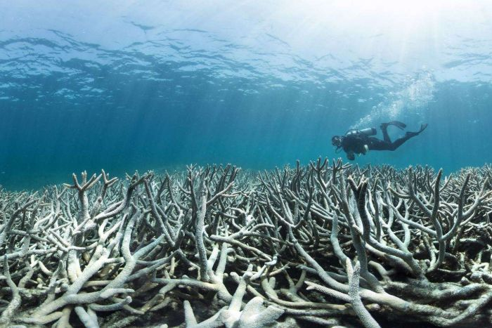

Healthy coral reefs are alive with the pops, snaps and clicks of the invertebrate creatures that inhabit them. And many newly hatched fish species use these sounds to guide them towards new habitats.

But now scientists have found reefs damaged by coral bleaching and cyclones are much quieter than intact reefs, and are failing to attract as many new juvenile fish, which are crucial for reef recovery.

"Those young fish graze the reef and keep the algae down. Without the fish suppressing the growth of algae, the corals have essentially no space on the reef and can't get through."

Dr Meekan said listening to a healthy coral reef through underwater audio amplifiers called hydrophones, was like "listening to bacon frying in a pan".

"But it's punctuated by the chirps and tweets and all sorts of screeches that come from fish."

The researchers compared underwater acoustic recordings from reefs around Lizard Island in the northern Great Barrier Reef off Cooktown from November 2012 and November 2016.

Between recordings, the reefs were hit by Cyclone Ita in 2014, Cyclone Nathan in 2015 and "the most severe global mass-bleaching event on record" in 2016.

The most recent recordings had "significantly reduced acoustic complexity, richness and rates of invertebrate snaps" when compared to the earlier recordings.

They consistently found fewer fish larvae and young fish were attracted to recordings made in 2016, compared to recordings from 2012.

[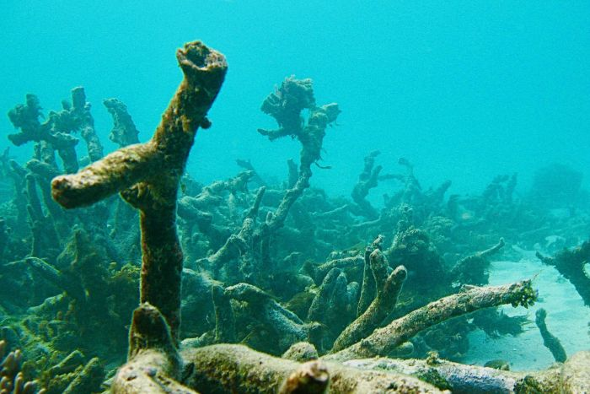](http://www.abc.net.au/news/science/2018-05-01/quiet-reefs-coral-bleaching-fish-stocks/9710348#lightbox-content-lightbox-17)

**Awesome Asteroids - The Big and Pretty Ones**

**Temperate colour shifters**

*Source: Australian Museum, Reef Life Survey,* [*http://portphillipmarinelife.net.au*](http://portphillipmarinelife.net.au)*, Echinoblog*

As with many marine species, obvious colours are not always the best way to identify species. What they eat and where they live can create a kaleidoscope of colour varieties within the same species.

**Mosaic Sea Star (Plectaster decanus).**

This is another example of rich colour variations in sea stars even of the same species.

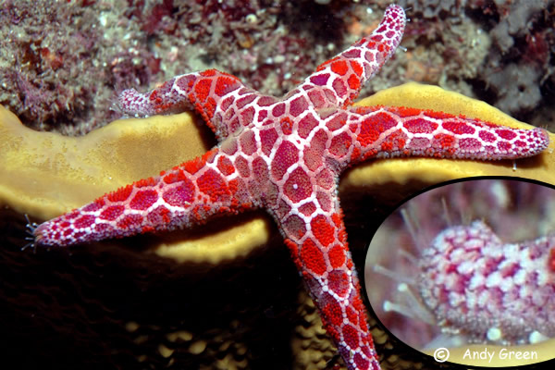

One taken at Julian Rocks NSW by Andy Green

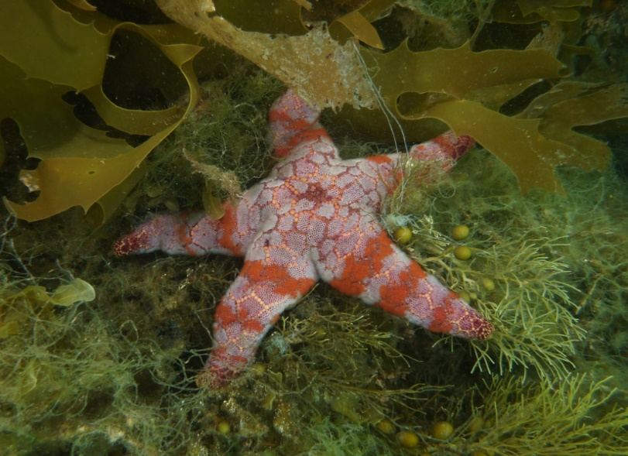

This is one of Dan Monceaux’s taken in the Tamar River Tas

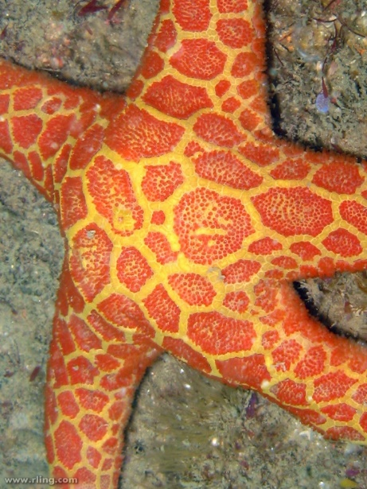

Richard Ling Forster NSW

**Awesome Asteroids - More Big and Pretty Temperate Ones**

*Source: Australian Museum, Reef Life Survey,* [*http://portphillipmarinelife.net.au*](http://portphillipmarinelife.net.au)*, Echinoblog*

**Pentagonaster dubeni**

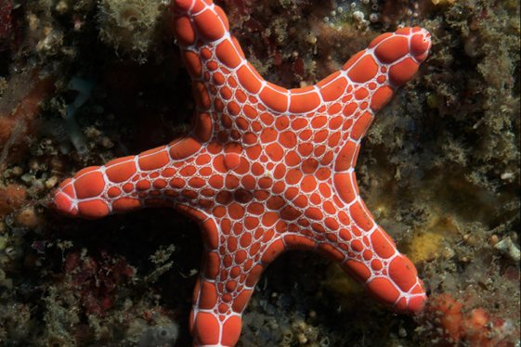

*Underwater Sydney*

This starfish inhabits temperate inshore and continental shelf areas from southern Qld south to Tasmania and west to Shark Bay, WA. Depth range 0-160M

**Nectria macrobrachia**

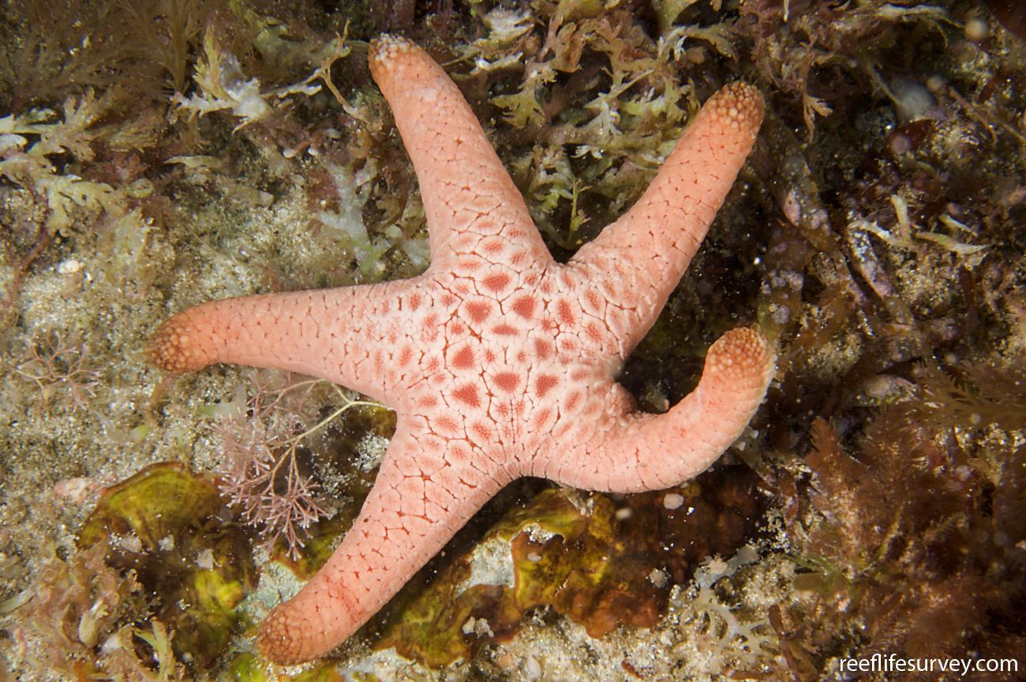

*Nectria macrobranchia, Chain of Bays, SA. Photo: Andrew Green Reef Life Survey*

This one is the smallest of the Nectria species

Little is known about these sea stars. They are found across the coast of Southern Australia amongst rocks and algae in sub-tidal areas, to a depth of 180 m.

**Velvet Seastar (Petricia vernicina)**

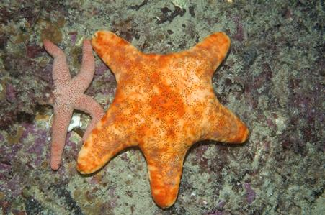

This large sea star is rarely seen and little is known of its biology. It lives amongst rocks and algae sub-tidally, to depth of 60 m in southern Australia.

**Firebrick Sea Star *(Asterodiscides truncatus).***

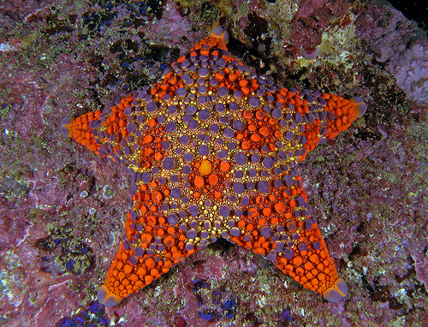

*NSW NPWS*

This 100 mm wide sea star is found inshore and in deep waters from Solitary Is., NSW, to off Eucla, Great Australian Bight WA, and Tasmania. Its recorded depth range varies from 14-804 m.

**The only pretty oceans are in the tropics**

***Many people associate underwater vistas with coral reefs, clear waters, and colourful tropical fish. Taking a holiday in colder water is often regarded as inferior. It is surprising how determined people are never to take a temperate waters ocean holiday, especially for diving or snorkelling activities in southern Australia.***

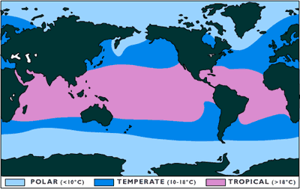Part of the problem is that people confuse tropical tourist resort diving with tropical diving.

I suspect that an average dive in the tropics near where people actually live, say a place like Surabaya Harbour in Indonesia, has a lot less colourful marine life and clear water than a comparable temperate place like the Derwent River in Tasmania. A fairer comparison would be beween tropical resorts and temperate resorts, but there aren't very many of the latter because tourists don't often come to the temperate zone to enjoy ocean activities.

Several people I know roundly criticise the sort of temperate diving I do locally, even though they have never really seen the reefs at their best, and some critics have never dived here at all (Hey Amy!).

***Temperate oceans are not cold.***

Temperate means just that, neither warm or cold but in between. Places like Tasmania are not in the polar region, it is not cold. It just isn't as warm as tropical locations (obviously). It is a lot colder if you aren’t use to it. It is true that under 18 degrees Celcius (which is anywhere in Tassie outside of Summer) many people find the water uninviting. You will simply need new gear and you need to take some time to adjust. (you might need to drink a cup of concrete too, as free Tas tourism advertorial aside, it is a shock in the first 10 seconds of a winter dive)

***There are important differences - Temperate diving and snorkelling can be harder to adjust to***

* Thick wetsuits or drysuits can be hard to put on and feel tight and smothering if you aren't use to it. The dive itself is fine with a good suit once you are in. You will need wind shelter or a drysuit in winter when you get out though.
* More weight - that means more uncontrolled ascents until you sort out your weight and get into the habit of being neutrally buoyant in a different suit.
* The water can be cloudier than you usually find at a tropical resort, it's easier to be separated from your buddy.
* Loss of manual dexterity due to the thick gloves. This can make you fumble even easy tasks, especially when your gear is new.
* You get tired more quickly as a lot of energy goes in to keeping warm. Tiredness can lead to mistakes. You won't want to do 4 dives a day in a temperate zone.
* Tropical resorts are often placed in sheltered spots, your local temperate adventure dive site may be more exposed and windy.
* A temperate adventure dive with friends is likely to take longer than a managed resort dive. No paid guide and boat operator. No-one fixes a drink for you when you forget your water bottle, no-one carries your tank. It's harder to get organised and you have to learn to be more independant.

***Temperate diving is an adventure***

* 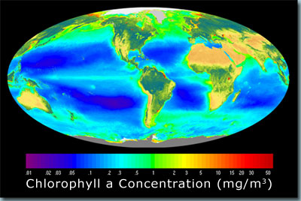Most temperate water diving is adventure diving outside of tourist resorts. You will pick up different skills like fixing gear, driving boats and reading the weather chart. That can be fun and is good for your confidence.
* Temperate adventure diving is also more social than resort diving. If you dive in the same group all year at your local dive spot, you get to know other local divers well, for better or worse. You also meet people from diverse backgrounds, all healthy stuff that makes even the coldest, blackest, heart grow.
* Temperate sites are often convenient. In Tassie there are a lot of sites near your house and you can even do a shore dive after work. You will get a lot more regular exercise, skills development and have more fun doing local temperate diving than waiting for your annual holidays to go to a tropical resort.
* Temperate adventure sites are often more varied and 'wild'. You aren't restricted to the same 6 postcard sites that everyone else visits at the resort.

Temperate diving is not on a different planet from tropical diving. With the proper techniques and practice, you will quickly get in to a routine and not really notice the differences.

***There is plenty to see on temperate dives***

The truth is that arguing about which sort of diving looks better is like comparing apples and oranges. Both have their strengths and weaknesses and they are just different, that's all. You need to try both temperate and tropical diving.

If all you are interested in is warm water and hate feeling cold, then I expect you will underrate the fact that temperate waters often have far more interesting marine life than many tropical dive sites, but it takes the form of rare and peculiar small animals like odd invertebrates, rather than clouds of fish in primary colours.

It is a scientific fact that the coastal regions of the temperate zones are more productive than the tropical zone. The Southern Ocean just south of Tasmania is one of the most biologically rich ocean systems in the world.

Tropical waters are well lit and have clear waters. This water clarity comes at a price. There is nothing much living in these nutrient-poor waters. The most remarkable thing about coral reefs is that they have such high fish species diversity with so little food on offer. That's because animals have to evolve lots of specialisations just to survive.

Temperate seas are rich in microscopic plankton which is the foundation of life in the sea. The fish are less varied to look at because life is easier. Cloudier water goes hand-in-hand with huge forests of seaweeds, big schools of fish, lots of majestic sea birds including penguins, and plenty of marine mammals like whales and seals.

Slightly rougher sea means a soup of nutrients waiting to be caught by the ancient and colourful animals that live welded to the sea floor. These sponges, sea squirts, marine moss and sea fans are just as colourful as any coral garden. These animals haven't changed much in shape in hundreds of millions of years, so a dive below 30 metres in Tasmania is also a dive back in time, back to what the ocean looked like before the dinosaurs.

The temperate areas of Australia have been cut off from other temperate areas by big open oceans and adverse currents for a very long time, so most species differ from place to place, especially seaweeds and invertebrate sea animals. A dive in northern Tasmania has different things to see than a dive in southern Tasmania. In the tropics there are site differences, but a skipjack trevally fish in Thailand is the same species as the one you will see in Cairns. A Tasmanian red handfish can only be seen in south east Tasmania and that species has been isolated in Australia unchanged for maybe the last 50 million years.

Corals reefs are definitely fascinating, but if your favourite resort is near a shallow inshore coral reef don't expect to see many big boulders, sea caves, big sea cliffs and other varied underwater formations. You can travel to see those (often on an expensive liveaboard) as they exist in the tropics too, but here in Tasmania that kind of varied underwater reef can be found a 30-60 minute drive from your home.

This doesn't mean that you will see a radically different mix of life or topography in every spot in Tasmania, any more than you can do that in the tropics. The point is that if you take the time to learn a bit about it, there is plenty to explore in both tropical and temperate Australia.

Take you annual tropical holiday by all means, but do your heart a favour and in between times get off that couch. Check out your local temperate reef. It's close, fascinating, fun and great exercise. It might take a little more time to get use to, but it's worth the effort. And No!...its not like the diving in the tropics! That’s why you need to try.

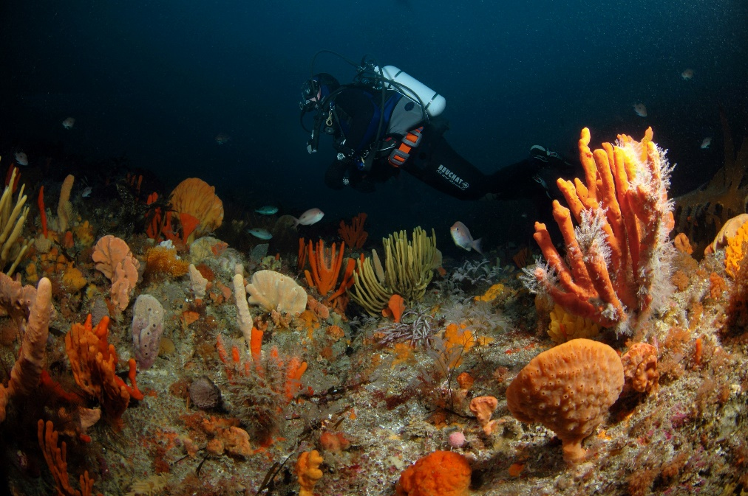

*Photo John Smith, Bicheno deep reef*

**Ningaloo Part II - Non Diving Attractions**

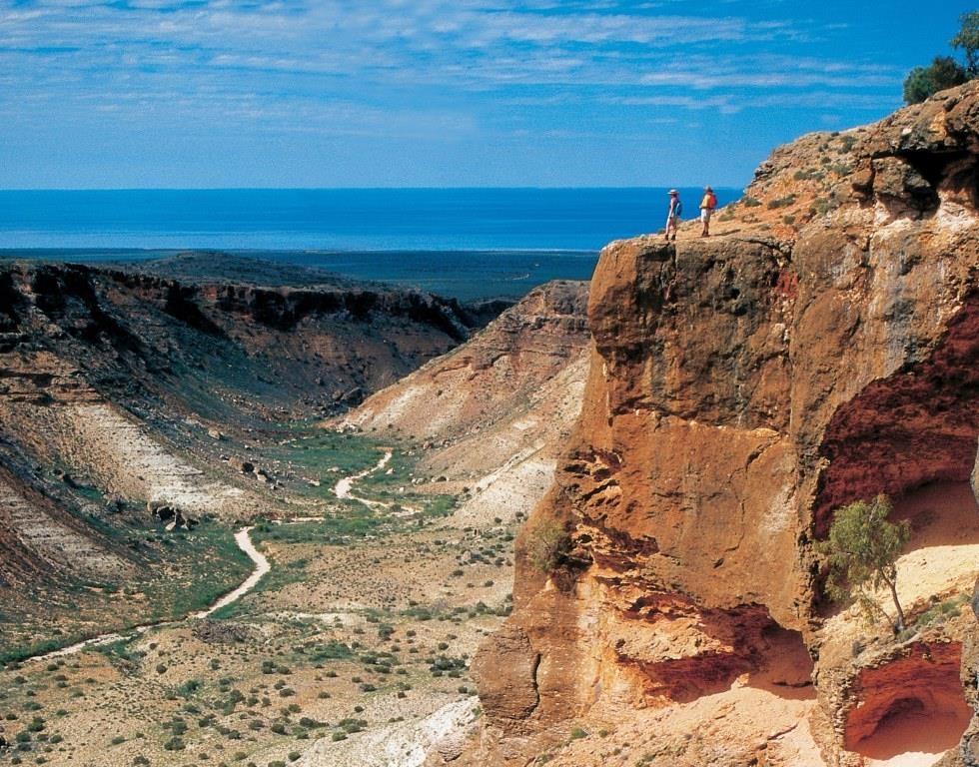***Water Sports***

Lots of snorkelling and water sports in the shallow lagoon. You will need a car if you aren’t happy with tour itineraries out of Exmouth and Coral Bay.

Pretty much the same as whale shark encounters but the whales tend to hand around longer and are easier to find. Huge numbers of humpbacks head up the coast for breeding at certain times.

***Whale Shark Encounters***

Plenty of on-line info, it is usually limited to snorkelling. They use spotter planes to ensure a good chance of an encounter, and it costs heaps.

***Sightseeing***

The area buts on to a huge costal national park with trails everywhere, some requiring a 4WD.

***Walking***

Some pretty terrific trails for the well-prepared and fit in Cape Range NP near Exmouth.

Cape Range National Park boasts several fantastic walk trails, many of which offer spectacular views over the range, canyons, Ningaloo Reef and Exmouth Gulf. However, caution should be exercised when bush walking the Cape Range National Park, especially around canyon areas which have steep walls and can be dangerous due to loose surfaces.

*Vlamingh Head (easy)*

The lookout at the base of Vlamingh Head lighthouse offers one of the best ocean views on the Ningaloo coast. A full panorama of the tip of North West Cape can be enjoyed here, which includes the Harold E Holt Communications Station VLF towers, Muiron Islands, offshore oil rigs, Ningaloo Reef and the township of Exmouth. Vlamingh Head is also a favorite place for visitors to watch the sun set over the sea or spot humpback whales during their annual migration from June to November.

*Mandu Mandu Gorge (rough)*

Mandu Mandu Gorge has a 3km walking trail which allows access into this dry gorge. The trail starts at the end of the Mandu Mandu track and follows the northern ridge of the gorge, offering stunning panoramic views of the gorge and the Ningaloo Reef. The trail leads down into the creek bed from where you follow the base of the gorge back to the car park. Please be aware this is a class 4 trail that is often rough and requires walkers to possess a moderate to high level of fitness.

*Yardie Nature Trail & Yardie Creek Gorge Trail (easy)*

The Yardie Nature Trail/Yardie Creek Gorge Trail is a 2km, two part trail that starts with a 1.25km, class 2 trail that requires no particular level of fitness. The Yardie Nature Trail follows a gentle, well defined path that winds along the edge of Yardie Creek, offering views of Yardie Creek and the Ningaloo Reef.

*But not the 750m Yardie Gorge Trail Section (hard)*

This is a class 4 trail that is often rough and requires walkers to possess a moderate to high level of fitness. The Yardie Gorge Trail takes walkers high above Yardie Creek with views over the gorge and Ningaloo Reef.

*Charles Knife Canyon (very easy drive)*

Charles Knife Canyon is accessed via Charles Knife Road, 21km south of Exmouth off Minilya-Exmouth Road. The mostly gravel road follows the razor-backed ridges of the range and provides breathtaking downward views into the stark, multicoloured gorges. There are several lookout points that provide fantastic photo opportunities and a marked walking trail from Thomas Carter Lookout.

*Badjirrajirra Loop Trail (rough)*

Badjirrajirra Loop Trail begins at the Thomas Carter Lookout, off Charles Knife Road. This is an 8km, class 4 trail that is often rough and requires walkers to possess a moderate to high level of fitness. A moderately difficult loop trail traversing the top of the Cape Range, the Badjirrajirra Trail winds its way through rocky gullies, small gorges and open spinifex bushland. The walk also offers views of Shothole Canyon and Exmouth Gulf.

*Shothole Canyon (easy)*

The access road into Shothole Canyon is located off Minilya-Exmouth Road, 14kms south of Exmouth. Shothole Canyon was named after the shot holes left by seismographic charge explosions during oil searches in the Cape Range during the 1950s.The 4WD only gravel road here follows the base of Shothole Canyon, offering close up examination of the colourful, fossil laden rock layers of the sheer canyon walls. At the end of the 12km road there is a picnic area and short walking trail.

**BEACHES**

*Exmouth Town Beach*: The closest beach to Exmouth is Town Beach. Located only 1km from the centre of town, this beach is ideal for morning walks, beachcombing and safe, protected swimming. 4WD access tracks that lead onto the beach can be found at the ends of both Warne Street and Willersdorf Road. This beach is tidal, so swimming is best at high tide.

*Bundegi Beach*: Located 12km north of Exmouth, Bundegi Beach marks the start of the Ningaloo Marine Park and is a great beach for swimming, kayaking and fishing. There is also a boat launching facility at the southern end of the Bundegi Beach.

*Lighthouse Bay:* Several short tracks along Mildura Wreck Road into Lighthouse Bay provide access to a variety of beaches suitable for fishing, surfing, swimming and sunbathing. At the end of the road you will discover the wreck of the cattle transport vessel, SS Mildura. which can be easily viewed from the beach. The Mildura was wrecked in 1907, with the loss of no human lives, although most of the cattle on board did not survive the disaster. The timbers and irons of the vessel were salvaged and used in renovations for Yardie Homestead, and the hull was later used for bombing practice by allied planes during World War II.

*Jurabi Coastal Reserve:* The access tracks along the Yardie Creek Road offer a variety of beaches to choose from. These beaches are suitable for fishing, swimming and [viewing nesting turtles](http://www.visitningaloo.com.au/things-to-see-do/turtle-nesting) during season (approximately November to March). On a low tide, close inspection of the rock pools hold many hidden delights such as sea urchins, anemones, starfish and octopus.

*Mauritius Beach*: Declared a 'clothing optional' beach in 1999, Mauritius Beach is located just past the Vlamingh Head lighthouse 21km from Exmouth.

*Beaches of the Cape Range National Park:* The beaches south of Tantabiddi lie within the [Cape Range National Park](http://www.visitningaloo.com.au/our-region/cape-range-national-park) and form the coastline of the Ningaloo Marine Park. These spectacular beaches - some of the best in WA - are great for relaxing, swimming or snorkelling. See [Snorkelling the Ningaloo Reef](http://www.visitningaloo.com.au/things-to-see-do/snorkelling)for more details.

*Turquoise Bay*: Located within the [Cape Range National Park](http://www.visitningaloo.com.au/our-region/cape-range-national-park), 63kms from Exmouth. Turquoise Bay is consistently ranked in the world's top 20 beaches by users of leading travel review website, TripAdvisor.com. The unique combination of white, sandy beaches with fantastic coral snorkelling only metres from the shoreline in calm, crystal clear water makes Turquoise Bay a must see.

CORAL BAY BEACHES

*Bill's Bay:* Located at the end of Robinson Street in Coral Bay, the sheltered waters of Bill's Bay make for an ideal swimming beach. Mere metres offshore you'll find thriving, fish filled coral gardens, making this beach a tourist  favourite. Bills Bay is within walking distance of all accommodation providers in Coral Bay.

*Paradise Beach:* Located south of Purdy Point just before Monk's Head rocky outcrop, Paradise Beach is a stunning beach with pristine white sands and crystal clear waters.

**Wilderness Camping**

**It is 2WD access to some accommodation but 4WD only to access the camping beaches.**

You must be fully self sufficient as no facilities or shops are provided.

Bring with you a chemical toilet and dispose of contents in the special chemical toilet stations provided on the property. You can hire toilets for $10 per day or $50 per week, from the Homestead or Caretakers at the 14 Mile.

Bring all your own wood or purchase from our Office or the caretakers at the 14 Mile, (please do not collect on Warroora) if you intend on having a campfire. Campfires only permitted May thru October.

Limited potable water is available at the Homestead, also artesian water showers, for a small fee.

*Ningaloo Station* <http://www.ningaloostation.com.au/camping>

*Waroora*<http://www.warroora.com/camping.php>

# **Do Australians ingest 11,000 pieces of plastic a year from fish?**

Our Goal

To educate, inform, have fun and share our enjoyment of the marine world with likeminded people.

The Crew

**Michael Jacques, Editor**

***SA Advisor – Peter Day***

***Media Monitor – Alison Triffett***

**Disclaimer:** The views expressed in this publication are not necessarily the views of the editorial staff or associates of this publication. We make no promise that any of this will make sense.

**Cover photo, *John Smith, Seals under boats***

We are now part of the wonderful world of Facebook! Check us out, stalk our updates, and ‘like’ ourpage to fuel our insatiable egos.

Contact us: marinelifetassie@gmail.com

**An environment group made this claim based on a BBC article *on shellfish consumption in Europe*.**

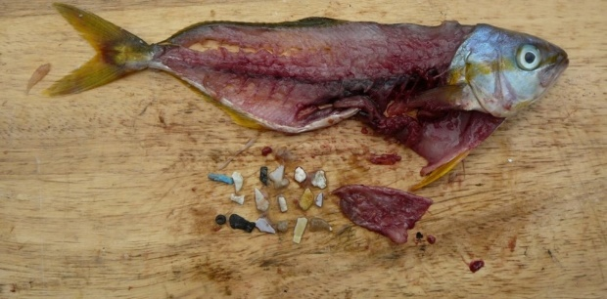

*Source Britta Denise Hardesty CSIRO*

The figure of 11,000 is an upper-end estimate for Europeans who eat quite a lot of molluscs from farms near cities. Small plastic particles can be ingested by bivalves (such as mussels, cockles, oysters, pipi and scallops) and remain there for some time. Unless you’re eating sardines and anchovies, humans don’t typically consume the digestive tract of a fish.

You should also note that microplastics have been getting everywhere and have recently been detected in a range of products such as milk, beer, honey and sea salt. “The presence of marine microplastics in seafood could pose a threat to food safety, however, due to the complexity of estimating microplastic toxicity, estimations of the potential risks for human health posed by microplastics in food stuffs is not (yet) possible.”

We obviously consume some microplastics in our food. It isn’t as much as is stated but we aren’t sure just how its harmful it is.